**BALOCHISTAN**

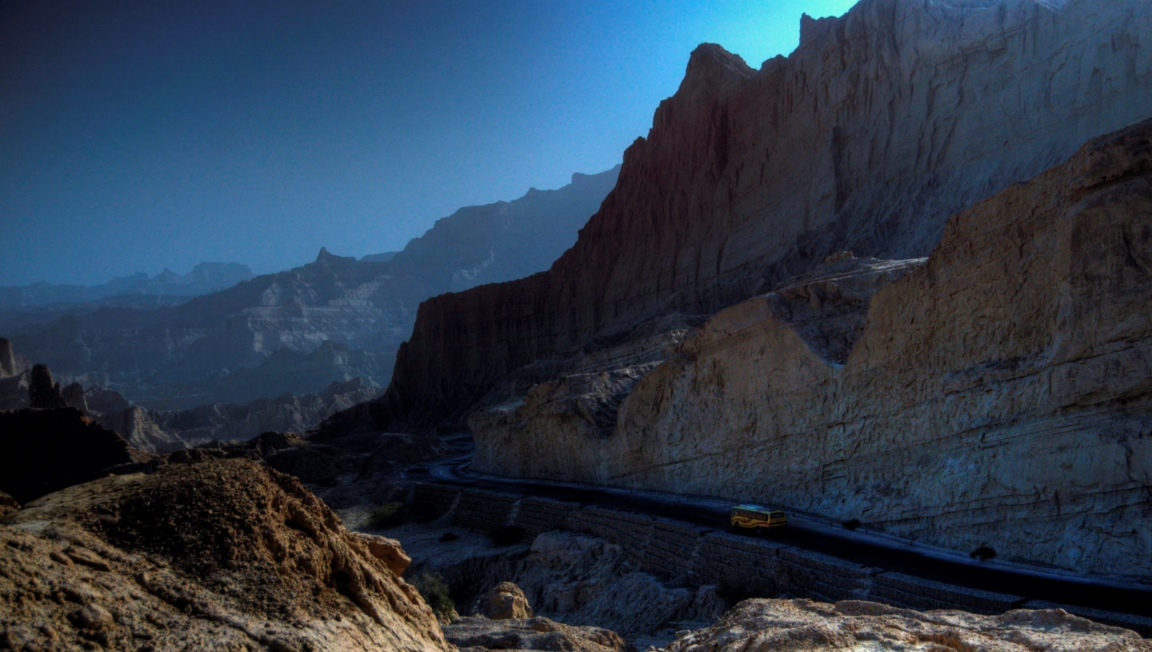

The province of Balochistan (or Baluchistan) in Pakistan contains most of historical Balochistan and is named after the Baloch. Neighbouring regions are Iranian Balochistan to the west, Afghanistan and the Federally Administered Tribal Areas to the north and Punjab and Sindh to the east. To the south is the Arabian Sea. The principal languages in the province are Baluchi, Pashto, Brahui, and Persian. The capital and largest city is Quetta.

Balochistan is located at the eastern edge of the Iranian plateau and in the difficult to define border region between Southwest, Central, and South Asia. It is geographically the largest of the four provinces at 347,190 km² and composes 42% of the total land area of Pakistan. The population density is very low due to the mountainous terrain and scarcity of water. The southern region is known as Makran. A region in the centre of the province is known as Kalat.

The Sulaiman Mountains dominate the northeast corner and the Bolan Pass is a natural route into Afghanistan towards Kandahar. Much of the province south of the Quetta region is sparse desert terrain with pockets of inhabitable towns mostly near rivers and streams.

The capital city is Quetta, located in the most densely populated district in the northeast of the province. Quetta is situated in a river valley near the border with Afghanistan, with a road to Kandahar in the northwest.

At Gwadar on the coast the Pakistani government is currently undertaking a large project with Chinese help to build a large port. This is being done partially to provide the Pakistan Navy with another base, and to reduce Pakistan's reliance on Karachi and Port Qasim, which are currently the only major ports.

**Kund Malir Beach:**

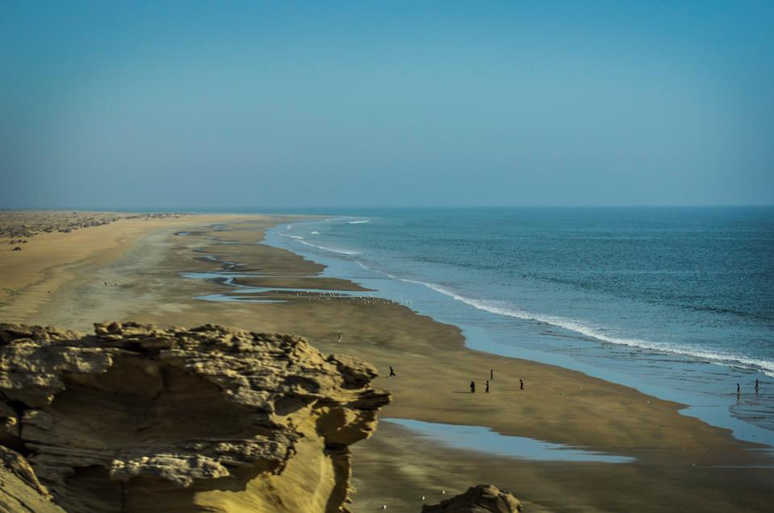

Kund Malir' is a beach in [Balochistan](https://en.wikipedia.org/wiki/Baluchistan_(Pakistan)" \o "Baluchistan (Pakistan)), [Pakistan](https://en.wikipedia.org/wiki/Pakistan) located in [Hingol National Park](https://en.wikipedia.org/wiki/Hingol_National_Park" \o "Hingol National Park), about 150 kilometres (93 mi) from Zero-Point on [Makran Coastal Highway](https://en.wikipedia.org/wiki/Makran_Coastal_Highway" \o "Makran Coastal Highway). It is located 236.8 kilometres (147.1 mi) west of [Karachi](https://en.wikipedia.org/wiki/Karachi), the largest city of Pakistan. The drive between Kund Malir and [Ormara](https://en.wikipedia.org/wiki/Ormara" \o "Ormara) is considered to be scenic. The area is part of [Hingol National Park](https://en.wikipedia.org/wiki/Hingol_National_Park" \o "Hingol National Park) which is the largest in Pakistan.

Kund Malir is a small town of Baloch fishermen, situated on a hill while the sea flows in its footsteps. Blue water and waves over the white sand attract the passers-by.

The construction of Makran Coastal Highway and the popularity of Kundu Malir on social media have given tourists an address here and now, besides the holidays, on the occasions of festivals are seen with their families enjoying the sea blue waters.

Kund Malir was included in the 50 most beautiful beaches of Asia last year. This ranking was done in terms of tourism and photography.

The sea is not much deeper here than the renowned beaches of Hawke’s Bay, Mubarak Village, and Kaka Pir, and that is why children and women also descend into the seafloor.

Despite being located in Balochistan, the majority of tourists coming to Kund Malir are from the people of Karachi, the capital of Sindh province, who come here in private cars or with tour groups.

According to those who come here says, ‘The Sea is clean here, there is also isolation, there is no rush of people. Families can come here because it is safe. ‘Furthermore, they did not see any dirt here the beaches of Karachi have dirty There are lying to children’s Pampers.

Most tourists coming to Kund Malir are on a ‘day trip’ but there are also people who spend the night here on the shores of the beach.

In this connection, some huts have also been constructed on the coast but their rent of Rs 15-20,000 is not within the reach of the middle class. There are several huts along the coast that are available in fifteen hundred to a thousand, and the majority of tourists to stay in.

Separate public toilets are also made for women and gentlemen and can be used after payment of Rs 30 per person.

Due to a lack of electricity, night tourists bring in generators or charged lights. ‘There is a very calm and tranquil environment and great scenery.

**Restaurant, accommodation, camping, food, refueling station**

**Hinglaj temple:**

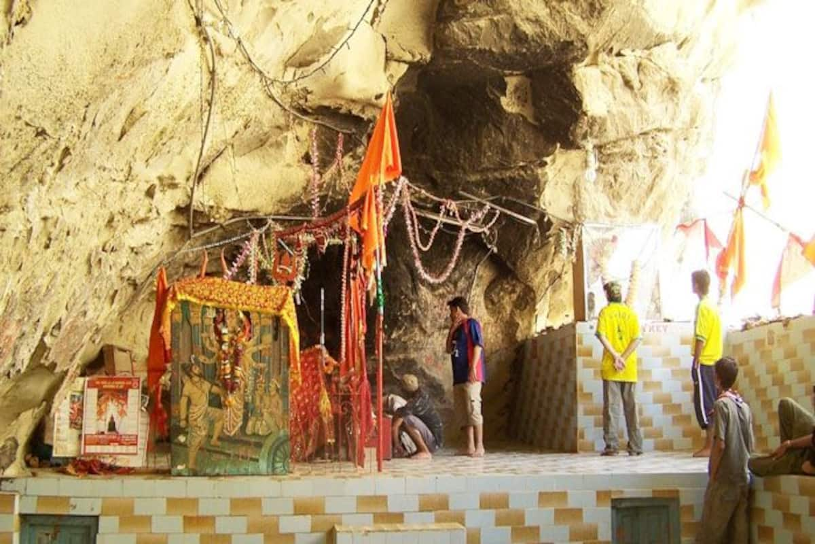

It is one of Pakistan's oldest Hindu temples

Hinglaj Mata also known as Hinglaj Devi, Hingula Devi and Nani Mandir, is a [Hindu temple](https://en.wikipedia.org/wiki/Hindu_temple) in [Hinglaj](https://en.wikipedia.org/wiki/Hinglaj" \o "Hinglaj), a town on the [Makran](https://en.wikipedia.org/wiki/Makran" \o "Makran) coast in the [Lasbela](https://en.wikipedia.org/wiki/Lasbela_District" \o "Lasbela District) district of [Balochistan](https://en.wikipedia.org/wiki/Balochistan,_Pakistan" \o "Hingol National Park), and is the middle of the [Hingol National Park](https://en.wikipedia.org/wiki/Hingol_National_Park" \o "). It is one of the 51 [Shakti Peethas](https://en.wikipedia.org/wiki/Shakti_Peethas) in [Shaktism](https://en.wikipedia.org/wiki/Shaktism) denomination of [Hinduism](https://en.wikipedia.org/wiki/Hinduism). It is one of the two [Shakti Peethas](https://en.wikipedia.org/wiki/Shakti_Peethas) in [Pakistan](https://en.wikipedia.org/wiki/Pakistan), other being [Shivaharkaray](https://en.wikipedia.org/wiki/Shivaharkaray" \o "Shivaharkaray). It is a form of [Durga](https://en.wikipedia.org/wiki/Durga) or [Devi](https://en.wikipedia.org/wiki/Devi) in a mountain cavern on the banks of the [Hingol River](https://en.wikipedia.org/wiki/Hingol_River" \o "Hingol River). Over the last three decades the place has gained increasing popularity and became a unifying point of reference for Pakistan's many Hindu communities. Hinglaj Yatra is the largest Hindu pilgrimage in [Pakistan](https://en.wikipedia.org/wiki/Pakistan). More than 250,000 people take part in the Hinglaj Yathra during the spring.

A tunnel at the shrine is associated with rebirth of an individual by purifying their soul. There are legends that the pilgrims have seen the goddess emerge from its statue. The tunnel has been extended, but its actual core is an overhanging rock above the statue. Colonial reports show that this practice was associated with pilgrims rolling out of this tunnel making baby sounds, thus experiencing things not just mentally but physically as well. It was also the climax of the pilgrimage.

**Restaurant, accommodation, food, refueling station**

**Hingol National Park:**

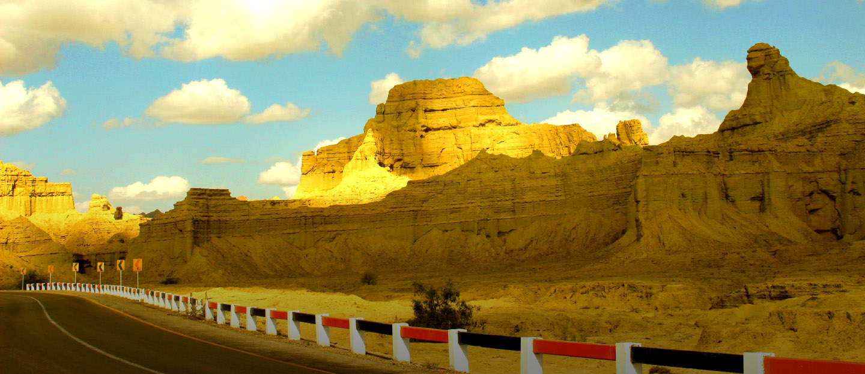

The adventure lovers of Pakistan are clearly having a low day. For with the mountainous north being too dangerous to venture into few places remain hospitable. Well here might just be the solution. Hingol national park is one of the most exotic and hospitable places in the country.

This beautiful park gloating over a portion of the country’s most delightful landscape could  just hold the cure to tourism starved Pakistan for it is a place teeming with wildlife, mud volcanoes, rugged rock formations and most importantly its adjacency to the beach only further ensures that it’s a place hard to miss.

If you haven’t heard about the Hingol National Park and judging by being a Pakistani myself, you probably haven’t than this is one of the biggest national parks of the country and only 190 Km away from Karachi.

The park’s beauty rivals that of the likes of Yellow stone park in US and with a rugged climate along the Makran beach, the park is as perfect as it can get for all sorts of adventure seekers, hikers, cyclists along with the beach lovers.

And if you are a wildlife photographer than this is the perfect place for you for this park not only contains a serene landscape but its vast reservoir of the rarest of wildlife creatures too makes it a place of global significance. The noble bird Houbara, marsh crocodiles, green marine turtles, threatened species of fish including Mahasheer, Plumbeous, dolphins, ibexes, Urials and Chinkaras all add to the beauty of the park.

Moreover astonishing rock formations make it a paradise for those who desire natural beauty. One unique rock formation in the park includes the Princess of hope whose special name was given by none other than the great Angelina Jolie of Hollywood fame, mesmerized by her very first look at it. The unique formation of this rock ensures that it has the potential to rival the Sphinx of Giza; if only our policy maker knew how to market tourism well.

The availability of Hindu Shrines too guarantees that if one day finally tourists from India manage to sneak in than this just might be the spot for them for the shrine of Devi Hinglaj in the park is considered among the 51 shakti peeths of Hinduism.

This valley has a phenomenal landscape of towering precipices, zeniths and braces with the river winding between. Some 350 miles in length, the river of Hingol is Balochistan’s longest waterway with streaming water in it.

**Restaurant, accommodation, camping, food**

**Bolan Pass:**

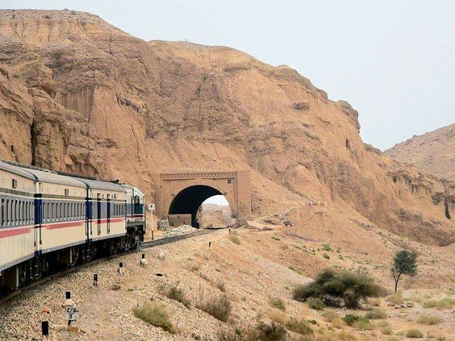

Bolan Pass is a high mountain pass at an elevation of 1.793m (5,884ft) above the sea level located in Balochistan province in western Pakistan. The pass has been used as a gateway to and from South Asia.

Located within the Toba Kakar Range of Balochistan province, the pass sits 120 kilometres far from the Afghanistan border. The road to the summit is paved. It’s called N65 (Quetta - Jacobabad Highway).  Adverse weather conditions are common. The Bolan Pass is only open at this time for locals and aid workers and it’s an alternative to the Khyber Pass further north. This area, as of mid-2012, is definitely not safe. Even with armed guards, travel is not recommended.

It's important to be prepared on this road. At a distance of 120 km from the border of Afghanistan, Bolan Pass connects the Jacobabad and Sibbi to the Quetta city. This pass has a significant history background being a mountain pass, which connects the Central Asia and South Asia. Along Bolan Pass where the road winds through picturesque mountains one is reminded of the huge odds that the armies from Central Asia and the South must have faced in their raids on the plains of the present day Pakistan.

**Restaurant, accommodation, camping, food, refueling station**

**Mehrgarh:**

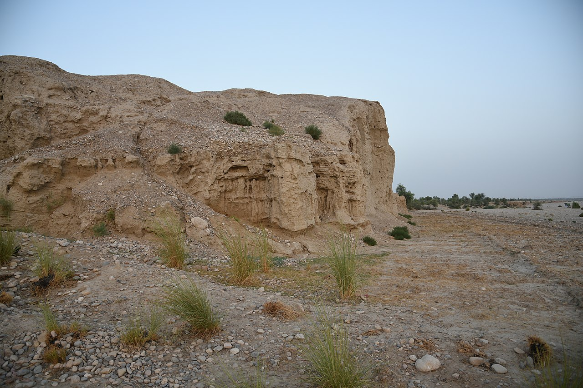

The ancient site of Mehrgarh lies at the foot of the Bolan Pass, on the banks of the Bolan River, not far from the modern city of Quetta in Balochistan in Pakistan. This has been a significant area in the Indian subcontinent’s history. From time immemorial, the Bolan Pass acted as a connector between the Iranian highlands and the Indus basin. It is through here that hunters, pastoralists, traders, invaders and others ventured into the land of the Indus, over thousands of years. It is also at the site of Mehrgarh, at its foot, that you will find clues to the dawn of India’s first civilisation – the Indus Valley or Harappan Civilisation.

The raw beauty of the area is hypnotic. But it wasn’t this primal pull that brought a French husband-and-wife team of archaeologists here in the 1970s. They came here hunting for an ancient settlement. What they found was momentous – a missing link!

There are eight different chronological phases at Mehrgarh. Seven of these are in a 300-acre area and the last almost 8 km from the main cluster. The archaeological levels are not really very deep. The importance of the site, though, lies in the simple fact that it destroyed one of the greatest myths then prevalent among Harappan scholars.

Before the discovery of Mehrgarh, most scholars believed that the Harappans had their antecedents either in the Mesopotamian or the Elamite civilisations to the West. The discovery of Mehrgarh put an end to this speculation and took a settled, agrarian way of life in the Indian subcontinent back to almost 8,500 years ago.

It was the search for these roots of Harappan Civilisation that led the husband-and-wife team of Jean-Francoise and Catherine Jarrige, both French archaeologists, to discover the site of Mehrgarh in 1974.

It was at Mehrgarh that archaeologists found the earliest-known remnants of the first farmers in South Asia. The excavations revealed 8 phases or periods, of which the most important for us are Periods 1-4.

The most interesting aspects of Period 1 at Mehrgarh were the discovery of advanced lapidary activities i.e. relating to the engraving, cutting or polishing of stones or gems, long-distance trade and the fact that they believed in a life after death and buried their dead with gifts for the afterlife.

**Restaurant, food, refueling station**

**Pir Ghaib:**

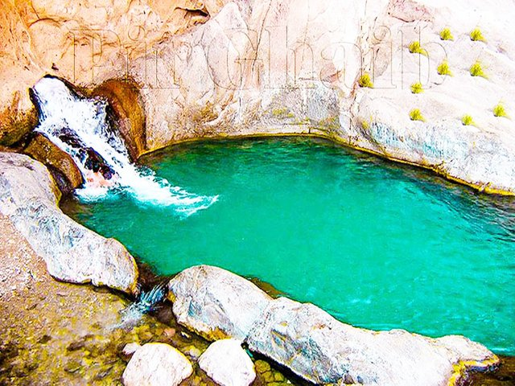

Pir Ghaib Waterfalls are waterfalls situated in the Bolan Valley, 70 km from Quetta, in Balochistan, Pakistan. Here a waterfall cascades down rocky mountain side making its way through many streams and ponds among the palm trees.

It is said that Pir Ghaib and his sister, the venerable Bibi Nani, arrived here to convert the local heathens in the early days of Islam. But the fire worshippers sent an army behind the pious pair.

This is an awe-inspiring view of Pir Ghaib, Balochistan. Locals here believe in the myth of the Invisible Saint, who was saved by the Almighty, after a wicked King’s men attacked him.  
The Saint struck a stick in the mountain from which the water still pours out till date, believe it or not.

IN the gorge of the Bolan, the siblings split; Bibi Nani went down the gorge while her brother fled into this arid landscape with the army in hot pursuit.  
At the head of the gorge, seeing that he was blocked by the rock wall,  
the saint prayed to Almighty to be rescued.

As is the wont of the Lord of all saints, He cleaved the rock to receive the holy man. And so he was known as Pir Ghaib – The Invisible Saint.

Local Hindus worship that Pir Ghaib as Mahadev. But, long before the Bolan gorge had rung with vedic hymns or invocations of the same Pir Ghaib (Invisible Saint), travellers and traders from the Indus Valley(area around indus river) would have stopped at this spring sacred to their own gods on the first leg of their long journey to Mesopotamian marts.  
As the vedic God Shivaderives from an earlier Indus Valley deity, so as it is known , and as the 5000 year old goddess Nania evolves into Bibi Nani or Durga, so too did the Pir Ghaib (Invisible Saint) develop from an early Indus Valley god.

But until the Indus script is understood we will not know which from this pantheon was celebrated for walking into rock walls.

**Restaurant, accommodation, food, refueling station**

**Princess of hope:**

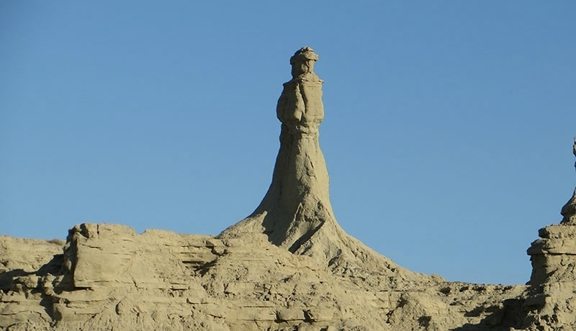

As soon as the name “Princess of Hope” is heard, it comes to mind that it is the name of an Egyptian princess, whose existence has lit a candle of hope among the people of that time. That is how she came to be called by that name.

However, apart from this thought that comes to mind, there is a different story of this princess. Let’s find out

***Who is this princess standing in the deserts of Balochistan?***

There are many coastal places and beautiful valleys in Balochistan province, which are unmatched. But people are not even aware of the beauty of many places, not even a princess who has been standing silent for years until a few years ago. However, this stone sculpture carved in the mountain range of the Makran Coastal is now known as the “Princess of Hope”.

The princess of this statue, located 190 km from Karachi, is dressed in a royal style. The tall princess looks elegant, but she looks as if she is hoping for something. The statue was named Princess of Hope in 2002 by the famous Hollywood actress Angelina Jolie. Angelina Jolie visited the area as a UN Goodwill Ambassador at the time and when she visited Hingol National Park, she saw the princess standing in the mountain range for years. This name came to her mind as soon as she saw this princess and she suggested the name of the princess of this statue which has been present at this place for years as “Princess of Hope”. The name of this princess of hope became popular again and this statue, which has existed for years, got recognition. Earlier, the statue, standing silently near the shores of the Arabian Sea, would have been hit by strong winds and dust storms, but it would have remained the same without its identity. There is another similar statue of the Sphinx at this place. It bears a resemblance to the famous Egyptian statue of the Sphinx, the only friend of the princess standing in this desolate desert. According to experts, these statues are 750 years old and historical heritage.

**Restaurant, camping, food**

**Sapat Beach:**

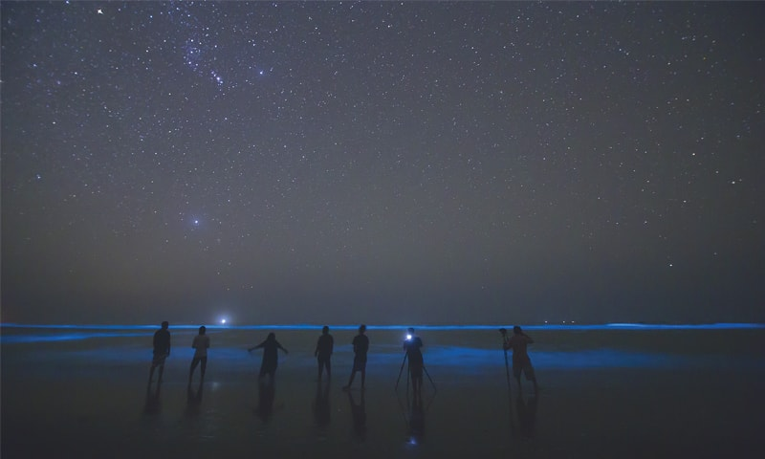

It is located about 220 km from Karachi at Labella district, Balochistan, Pakistan.  
The beach is home to a curious rock formation called Bujih Koh — a steep cliff rising from the sand entirely on its own.  
It’s separated from the cliff wall that stretches along the coast straddling the beach between its rocky embrace and the sea.  
The entire beach is home to a healthy colony of crabs. Another interesting feature about this beach is that there are some caves on the cliffs.  
The beach is an entirely different entity at night. On full-moon nights, when the rays strike the surf of the incoming waves, they almost seem to glow.  
Luckily Pakistan also has bioluminescence at Sapat beach in Balochistan, Pakistan.

**Restaurant, camping, food**

**Kharan Desert:**

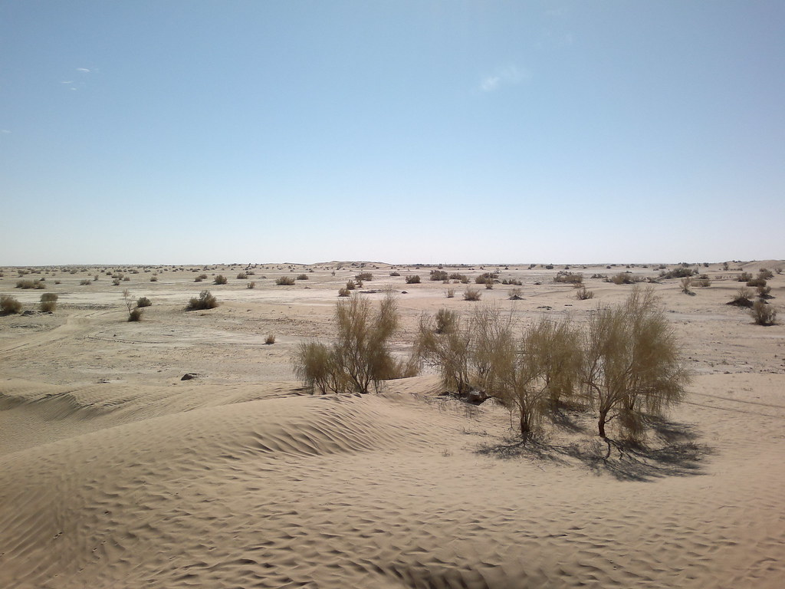

The Kharan Desert is located in Northeast Balochistan. The desert was used for nuclear testing by the Pakistan military, making it the most famous of the five deserts. It is in the center of a large empty basin. It estimated area of more than 20,000 Square KM.

The Kharan Desert, also known locally as the Sandy Desert. Pakistan, a mostly a dry country characterized by extremes of altitude and temperature, has three main river basins: Indus, Kharan and Mekran. The Indus Plain extends principally along the eastern side of the river, and the Balochistan Plateau lies to the south-west. Four other topographic areas are the narrow coastal plain bordering the Arabian Sea; the Thar Desert on the border with India; the mountains of the north and north-west; and the Kharan Basin, to the west of the Balochistan Plateau. The Kharan Basin is known as a closed basin because the entire basin's catchment water is used for agriculture and domestic requirements. The Kharan Desert area consists of shifting sand dunes with an underlying pebble-conglomerate floor. The moving dunes reach heights of between 15 and 30 meters. Level areas between the dunes are a hard-topped pan when dry and a treacherous, sandy-clay mush when wet. The barren wastes that occupy almost half of Iran, with its continuation into Kharan in Pakistan, form a continuous stretch of absolute barrenness from the alluvial fans of the Alborz mountains in the north to the edge of the plateau in Baluchistan, more than 1,200 km to the southeast. In altitude these central deserts slope from about 1,000 m in the north to about 250 m on in the southwest. Average annual rainfall throughout these deserts is well under 100 mm. The desert includes areas of inland drainage and dry lakes (hamuns). The Gowd-e Zereh (lake basin) in Iran, which occasionally receives excess drainage, is separated from Kharan in Pakistan by the low Chaghai hills, which, with the highlands around the extinct volcano Koh-e Tafta'n, cause the Mashkel river to form a lake. The surface of the Hamun-i-Mashkhel, which is some 85 kilometers long and 35 kilometers wide, is littered with sun-cracked clay, oxidized pebbles, salty marshes and crescent-shaped movisng sand dunes. The area is known particularly for its constant mirage and sudden severe sand-storms.

**Restaurant, accommodation, food**

**Ziarat Juniper Forest:**

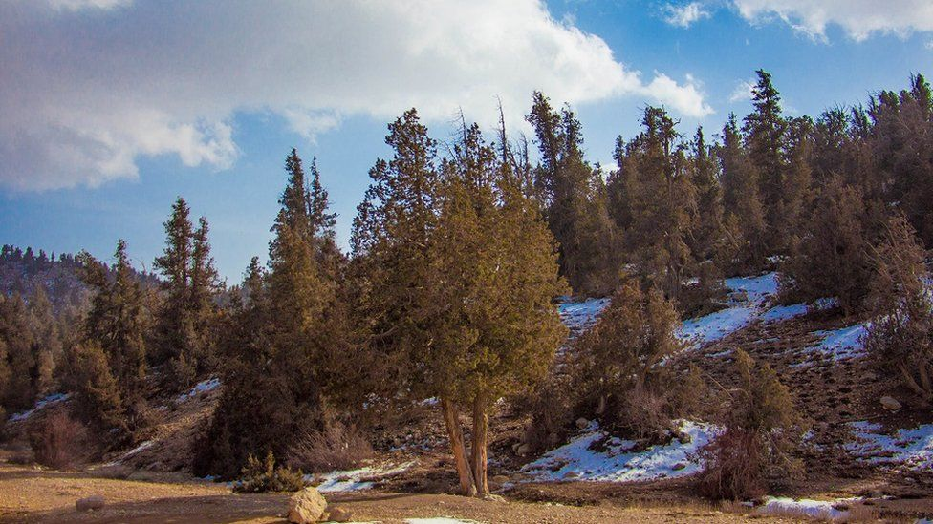

The Ziarat area is home to the largest area of juniper forest (juniperus excelsa polycarpus) in Pakistan, covering about 110 000 ha., and is believed to be the second largest of its kind in the world. The junipers of Ziarat are among the oldest living trees in the world. Although no dendrological study has yet been conducted, according to one estimate mature trees are often thousands of years old. Local people refer to the trees as „living fossils‟ and this remarkable longevity allows research into past weather conditions in the region, making the species of special significance for climate change and ecological studies.

The forest lies in the mountain zone with elevation ranging from 1,181 to 3,488 masl and contains high species diversity. The Ziarat Juniper Forest ecosystem is located at the junction of five vegetation zones. The plant species constituting the vegetation cover therefore offer a unique combination of five different vegetation types, which makes it a distinct global site from plant composition point of view. The vegetation of Ziarat forest ecosystem includes species from: Western Irano-Turnian Sub-region, Eastern Irano-Turanian Sub-region, Sino-Japanese Region, Indian Region and Saharo Sindian Region The mountain ranges, including Khalifat Mountain, provide a habitat for endangered wildlife species; recorded mammals include endangered species such as Balochistan Black bear (also called Pakistan Black bear, which is a sub-species of the Asian Black bear), Ursus thibetanus, and the Sulaiman Markhor, Capra falconeri jerdoni, and birds such as Chukar, Mistle thrush, Dark throated thrush, Streaked Laughing Thrush, Simla Black Tit and Bar-tailed Tree Creeper. It also supports a rich diversity of plant species; including other trees such as Wild Ash, Wild Pistachio, Wild Almond, Makhi, Surai and Zralg. The essential oils of branchlets and fruits of the juniper (juniperus excelsa polycarpus) have antioxidant qualities that have made it an important medicinal plant since antiquity. The Ziarat forest also contains a rich diversity of plant species of medicinal significance with over 50 per cent of the 54 catalogued species known to have medicinal or ethno-botanic value, which local people use as indigenous treatments for a variety of diseases.

The Ziarat Juniper Forest was declared a Biosphere Reserve in 2013 as a model region for researching and demonstrating successful approaches to protection and sustainable development. In accordance with UNESCO specifications, it is divided into a core area, buffer zone and transition area defined by how greatly they are affected by human activity. It also operates a biosphere management system.

During the Earth Summit 2002 it was highlighted that old forests have global significance in terms of dealing with the threats from climate change. Due to its large area and old growth trees, the Ziarat Juniper Forest ecosystem as part of the global forest vegetation has assumed immense importance as carbon stock. It is predicted by the UN-REDD+ programme of Climate

Change that such forests will play a vital role in storing amounts of carbon in their biomass and soils and that in the future these forests will play a pivotal role in furthering the cause of carbon sequestration.

**Restaurant, camping, food, refueling station**

**FAISALABAD**

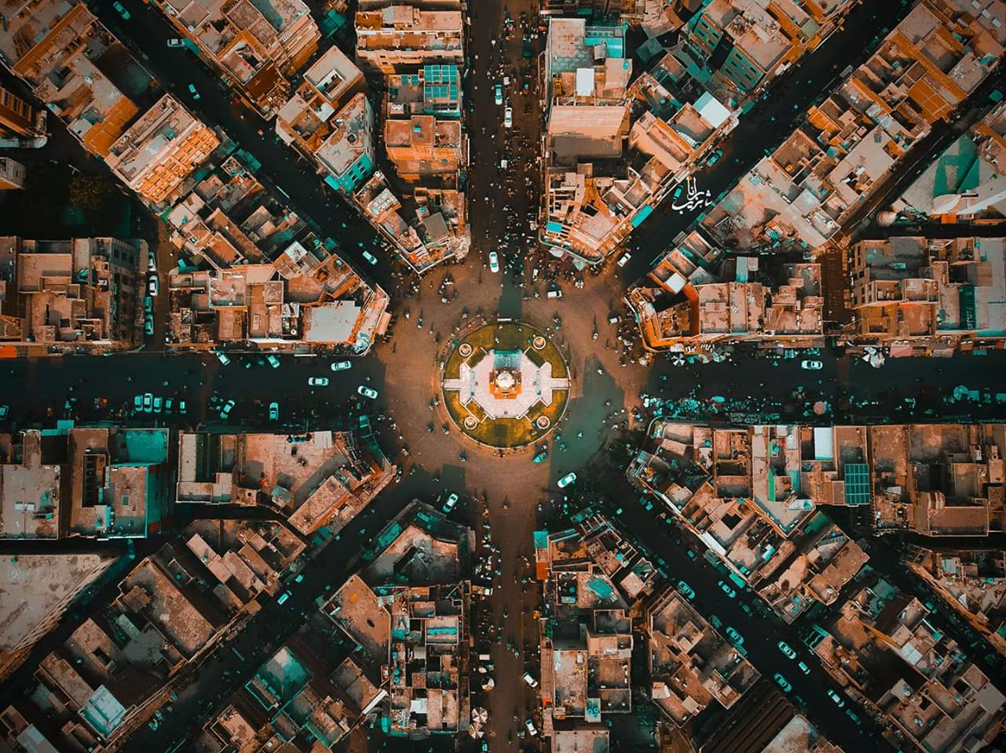

Faisalabad is one of the biggest cities in Pakistan. As a matter of fact, it falls behind only Lahore and Karachi in size, making it the third-largest of Pakistani cities. However, it is a bit younger than the other two cities, even if nomadic peoples were already stopping by its location long ago: true city development started fairly recently, especially compared to Lahore. It went through a number of names too, from Chenab Colony to Sandalbar then to the still-used Lyallpur and finally to the current and official name of Faisalabad.

While Faisalabad is a lovely metropolis and undoubtedly one of the fastest-expanding cities of Pakistan, it unfortunately pales in tourist appeal when compared to nearby Lahore, which is teeming with monuments and even has a number of candidates for World Heritage Sites. This is no doubt due to Faisalabad’s youth. That said, it is nonetheless a wonderful place to come to see, especially if you have an interest in Pakistan’s modernisation. This is the city referred to as the Pakistani Manchester, so named because of its importance to the national economy. No less than a quarter of the country’s total revenues from commerce and trade come from this city.

This is thus a good place to see if you want to get a feel for Pakistan at its most bustling, expanding and modernising. Do not be fooled into thinking it a place of purely industrial facilities and international franchises like the McDonald’s on the corner or the KFC branch nearby: alongside the pulse of commerce and modernity lives a very real, still-very-relevant traditional character, emphasised by the fact that this is one of the biggest agriculture centres of Pakistan. Here you get the fields as well as the factories.

There are thus [shopping malls](https://cushtravel.com/the-quick-guide-to-shopping-in-pakistan/) galore in the area, as well as parks and even a Happy Land Water Park for families interested in a little water fun: it is the biggest park of its kind in the country, in fact. You can get fantastic prices on textiles and textile products here, given the city accounts for more than half the total of the national textile industry. The 25,000-seater Iqbal Stadium is also available if you want to watch some cricket; check the listings if there are any games going on.

Faisalabad may not have as many old monuments as Lahore, but there are still places of historic interest here, including the Ghanta Ghar or Faisalabad Clock Tower. Around the huge clock are eight markets that are worth a visit from the shopping traveller, as well as a number of old buildings that were built by the British and left behind. There are also a number of local shrines to see here if you are interested in Sufi saints: just ask the locals and they should be able to direct you to one. Finally, there is the [marvelous cuisine](https://cushtravel.com/a-guide-to-eating-and-drinking-in-pakistan/), which represents Punjabi food at its best: diverse, flavourful, and among the most well-received cuisine styles from this part of the world.

**The Clock Tower:**

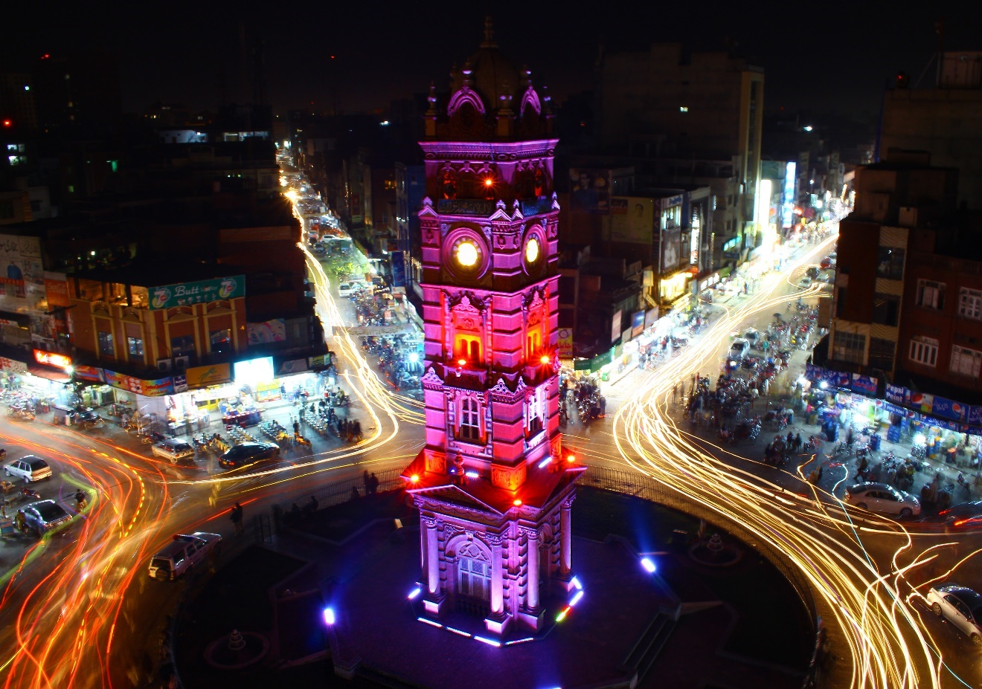

The historical Clock Tower, a throwback to the days of British rule. The tower was constructed during the period of the British Raj, at a point where eight roads were designed to meet and form a pattern representing the Union Jack. From a bird’s-eye view, you can see the Union Jack, with the tower in the center. At the beginning of 20th century, local agriculturists raised funds to erect the monument, which remains preserved its original form and boasts a remarkable architectural style. The surrounding area contains numerous shops and restaurants. Arrange to visit Clock Tower and other attractions in Faisalabad using our [Faisalabad journey planner](https://www.inspirock.com/pakistan/faisalabad-trip-planner).

Faisalabad’s Ghanta Ghar or Clock Tower is located within its city(Faisalabad) center. The Clock Tower was founded in 1903 by Sir Charles Riwaz who was the British Lieutenant Governor of Punjab. It is an architectural marvel to behold. However, what’s unique about this site is not the clock tower itself, but the fact that an aerial view of the area forms the Union Jack, which is the British flag.

Surrounding the clock tower are 8 different markets, each named after an area or city that it is directed towards. These markets are:

1. Chiniot Bazaar
2. Karkhana Bazaar
3. Jhang Bazaar
4. Katchery Bazaar
5. Amin Pur Bazaar
6. Montgomery Bazaar
7. Bhowana Bazaar
8. Rail Bazaar

**Lyallpur Museum:**

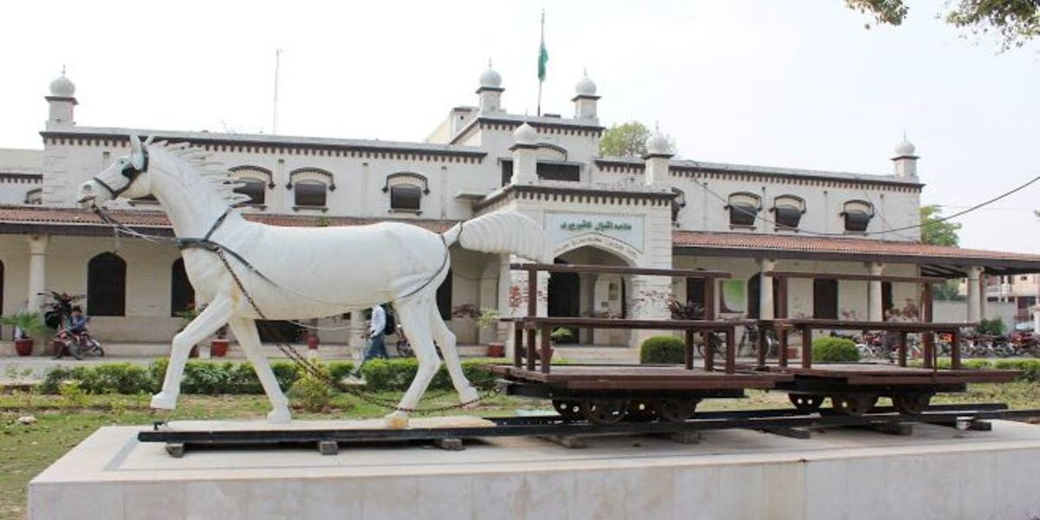

Lyallpur Museum is a heritage museum in Faisalabad, Pakistan ( the old and original name for the city of Faisalabad is Lyallpur). It has 10 galleries which show the ancient and modern history and culture of Lyallpur/Faisalabad. It was established in 2011 by the Chief Minister Punjab, Mian Shahbaz Sharif, following a proposal from Dr M Aamer Sarfraz (consultant and DME). The foundation committee consisted of Dr Aamer Sarfraz (Chairman), Dr Touqeer Shah (Secretary to Chief Minister), Haseeb Athar (Secretary Education) and Saeed Wahlah (Divisional Commissioner Officer) It has a Board of Governors now headed by the Commissioner, Faisalabad Division.

Various collections are displayed in 10 different galleries within the museum. These galleries are:

1. Orientation Gallery
2. Regional Heritage Archaeological Gallery
3. Chenab Colony Gallery
4. Sandal Bar Gallery
5. Thought and Act Gallery
6. Pakistan Movement Gallery
7. Social Beauty Gallery
8. Muslim to Sikh Period Gallery
9. Textile Gallery
10. Lyallpur Gallery

Lyallpur Museum is located on University Road in front of Faisalabad District Council and close to District courts. Car access is from either Katchehry Bazaar or University of Agriculture (Faisalabad) Main Campus. Public transport system also provide access to Lyallpur Museum.  
People can also enjoy a virtual visit of Lyallpur Museum.

**Jinnah Gardens:**

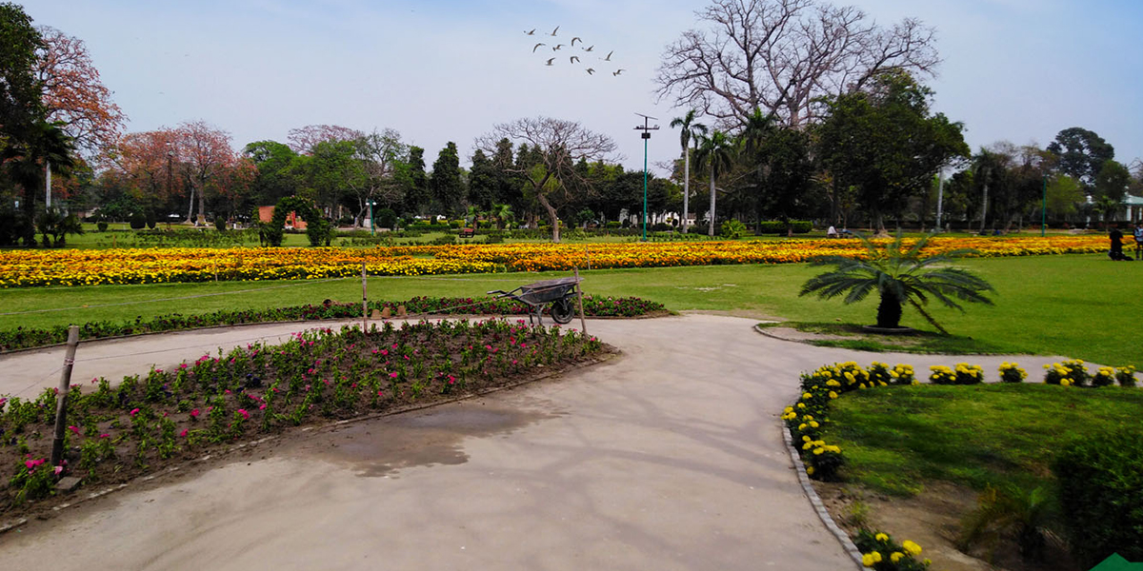

18-year-old Jinnah Garden is another historical and attractive place for picnic point of view. [Jinnah Garden](https://www.tripadvisor.com/Attraction_Review-g304030-d8599114-Reviews-Jinnah_Gardens-Faisalabad_Punjab_Province.html) is located in Faisalabad. When someone comes in Faisalabad to visit they should visit Jinnah Garden Faisalabad. It is a central park of Faisalabad and also known as company Bagh Faisalabad. In 1902 British Government decided to establish gardens in every big cited name by Company bagh and the reason is many British officers live near Bagh, and they need places for Entertainment

Jinnah Bagh, which is also known as company bagh, is the biggest Park in the city after [D ground Park](https://faisalabadinfo.com/d-ground-park-faisalabad/). It has recently been decorated and renovated for people because the Government want to create and manage more places for visitors and promote tourism.

Jinnah Garden Faisalabad is a 1.3 mile almost 3,000-step area covered. Jinnah Garden is named over the Founder of Pakistan Quaid e Azam Muhammad Ali Jinnah. It contains a Baradari (12 Sides), kids zone and more. Govt. installed and old waterjet in the front of the Park for attraction to the public. This war jet was used in the war between Pakistan and India, Pakistan Air force showcase this jet.

This jet increase the beauty of the park and welcome to the visitors  Near the plane, a well-known fruit chart shop is there for Entertainment.

In Jinnah Garden Faisalabad, 4 km jogging track is beautifully and artistically planned because we know Faisalabad is a populated city and there are some places for such activity like jogging and morning walk. There are a lot of very old trees which shows the history of Park. For children attraction include exercise place and swings. The flowers are of many varieties which makes a beautiful view for everybody. The grass plots are well maintained by the workers of Park.

In other facilities, there is a tuck shop, library and mosque in the Park. In the morning many people come for relaxing his minds in a cool atmosphere. It’s a small paradise of the Faisalabad. This Bagh is Contains The H. E Sir Charles James Lyall, who is the founder of this city, and the city was the first-named Lyallpur in his honour. Howe ever later it was named to Faisalabad.

**Lyallpur Galleria:**

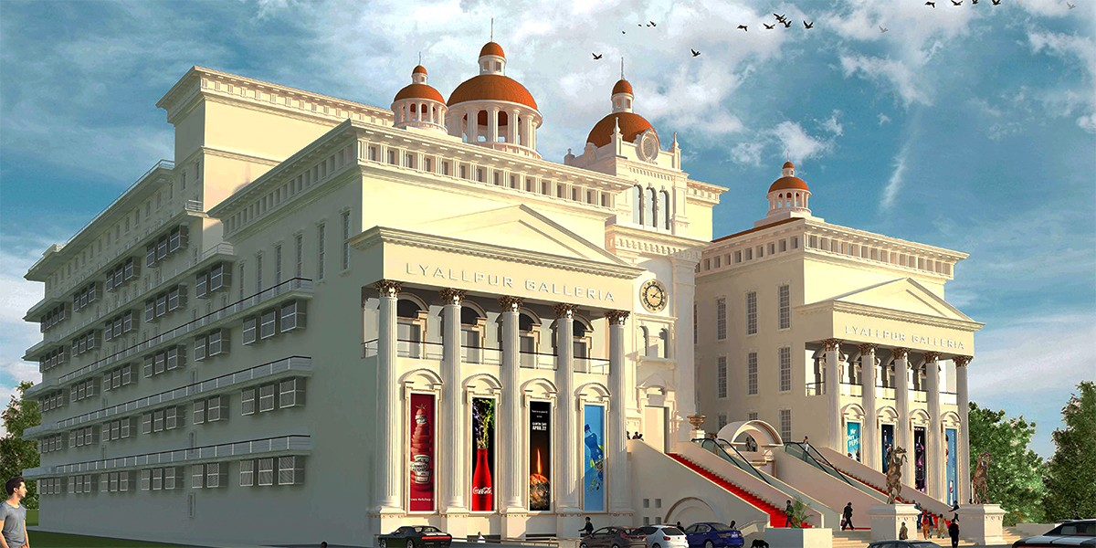

Lyallpur Galleria Faisalabad is the biggest name of all Shopping Malls in Faisalabad city. Being located on the elite class area of Faisalabad- the Canal Road, Lyallpur Galleria enjoys the pivotal position connecting people all over Faisalabad and its suburbs. It’s beautifully crafted architecture is not only and an attraction to the visitors but it is spacious as well. The Royal Look is a different yet remarkable thought adding magic to the beauty of Faisalabad city.

This project by has the utmost potential in renovating the whole shopping and residential experience in Faisalabad. Based on 4 monstrous floors, it allows us to enjoy and experience fun, shopping and stay with extravagant and lavish suites with exceptional service. It has brought world’s most renowned brands or eateries and shopping under a single roof. This landmark project has added a shining star to the commercial face of Faisalabad city to make it the only destination for its people.

Different Brands, Food Chains and Other entertaining activities Like Cinema and play area for children are available. The architecture of Lyallpur Galleria Faisalabad Presents Royal Look. Every one passing front of Galleria adding some magic thoughts about the beauty of Faisalabad city.

**LAHORE**

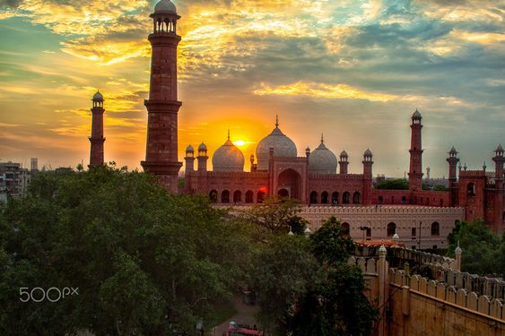

Lahore is a stunning old city and is widely considered to be the cultural capital of Pakistan. It has gone through many transformations and since its establishment around the second century, the city has passed through many conquering hands, from Hindu, Moghul and Persian to Afghan, Sikh and British.

Part of Lahore's inner city is dotted with remnants of colonial architecture: a magnificent post office, white-pillared government buildings and a stunning gothic-esque cathedral. The other part is dominated by Moghul architecture, with shops and eateries crammed in among the 'gates' to the centuries old walled city.

Punjab, with Lahore as its capital, dominates Pakistan in many respects. It is the most populous and prosperous province by far, accounting for over 55% of Pakistan's population and 59% of its GDP. Punjab's dominance is the source of much tension in Pakistan, as other provinces fear of the 'Punjabization' of the country. So much so that a proposal to split Punjab, creating a new fifth Pakistani province, is currently before the federal parliament.

Lahore has much of the same fantastic Moghul-era architecture as India boasts, but without the hordes of Western tourists. Lahore Fort (left), whose construction dates back to Moghul Emperor Akbar's time in the 16th century, was empty when we arrived early on a Saturday morning, save a few boys playing cricket outside the *diwan-i-am* (hall of public audience).

**Badshahi Mosque:**

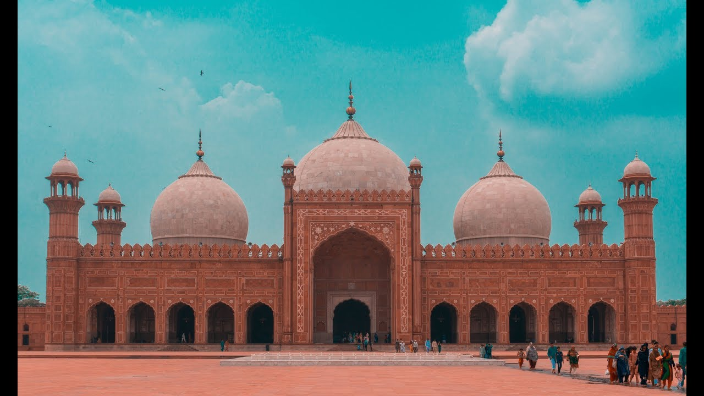

Considered one of the last great monuments of the Mughal period, the mosque remains the largest on the Indian subcontinent. It is adjacent to the western wall of the Lahore Fort, and was commissioned by Emperor Awrangzib (1658-1707) to house a number of relics of the Prophet. The scheme is based upon that of the Jami Masjid of Shahjahanabad, Delhi, and uses similar materials --red sandstone decorated with white marble-- that depart from the tilework facing typical of Lahore architecture.

The mosque stands in a walled enclosure with high minarets at each corner, the whole built upon a high plinth that raises it above the city and Fort. Another set of minarets marks each corner of the mosque itself. The façade is arcaded, with a high central Iran. Three white marble double-domes, the central one slightly larger than the others, complete the composition. The interior is decorated with elaborate floral and cartouche motifs in painted plaster reliefwork, as well as with white marble inlay.

**Shahi Qila (Lahore Fort):**

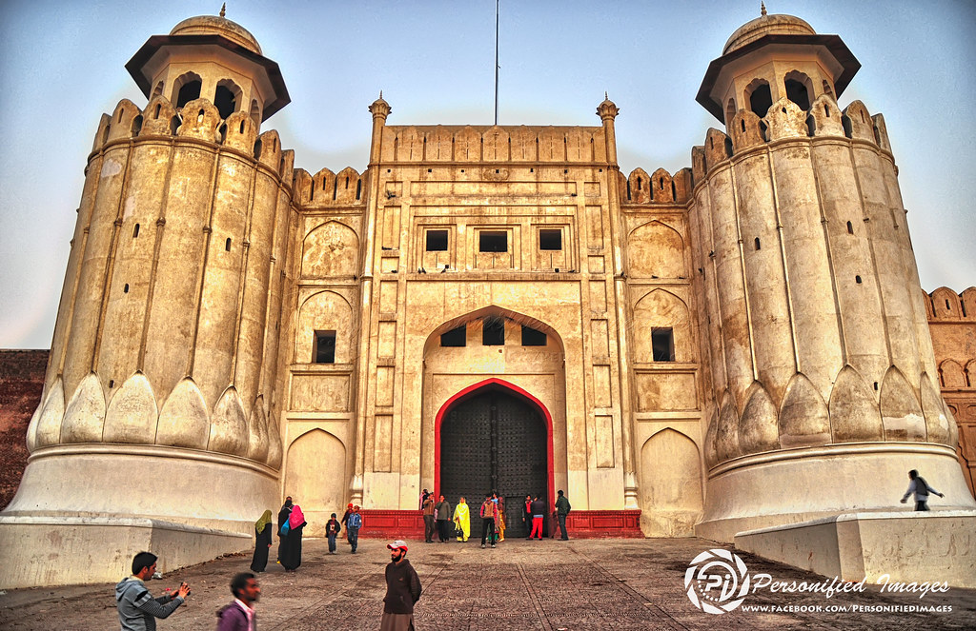

The Lahore Fort (Shahi Qila, or "Royal Fort") is a [citadel](https://en.wikipedia.org/wiki/Citadel) in the city of [Lahore](https://en.wikipedia.org/wiki/Lahore), [Punjab](https://en.wikipedia.org/wiki/Punjab_(Pakistan)), [Pakistan](https://en.wikipedia.org/wiki/Pakistan). The fortress is located at the northern end of [walled city Lahore](https://en.wikipedia.org/wiki/Walled_City_of_Lahore), and spreads over an area greater than 20 [hectares](https://en.wikipedia.org/wiki/Hectare). It contains 21 notable monuments, some of which date to the era of Emperor [Akbar](https://en.wikipedia.org/wiki/Akbar). The Lahore Fort is notable for having been almost entirely rebuilt in the 17th century, when the [Mughal Empire](https://en.wikipedia.org/wiki/Mughal_Empire) was at the height of its splendour and opulence.

Though the site of the Lahore Fort has been inhabited for millennia, the first record of a fortified structure at the site was in regard to an 11th-century mud-brick fort. The foundations of the modern Lahore Fort date to 1566 during the reign of Emperor Akbar, who bestowed the fort with a syncretic architectural style that featured both Islamic and Hindu motifs. Additions from the [Shah Jahan](https://en.wikipedia.org/wiki/Shah_Jahan) period are characterized by luxurious marble with inlaid Persian floral designs, while the fort's grand and iconic Alamgiri Gate was constructed by the last of the great Mughal Emperors, [Aurangzeb](https://en.wikipedia.org/wiki/Aurangzeb), and faces the renowned [Badshahi Mosque](https://en.wikipedia.org/wiki/Badshahi_Mosque" \o "Badshahi Mosque).

After the fall of the Mughal Empire, Lahore Fort was used as the residence of Emperor [Ranjit Singh](https://en.wikipedia.org/wiki/Ranjit_Singh), founder of the [Sikh Empire](https://en.wikipedia.org/wiki/Sikh_Empire). The fort then passed to [British colonialists](https://en.wikipedia.org/wiki/British_Raj) after they annexed Punjab following their victory over the Sikhs at the [Battle of Gujrat](https://en.wikipedia.org/wiki/Battle_of_Gujrat) in February 1849. In 1981, the fort was inscribed as a [UNESCO](https://en.wikipedia.org/wiki/UNESCO) [World Heritage Site](https://en.wikipedia.org/wiki/World_Heritage_Site) for its "outstanding [repertoire](https://en.wiktionary.org/wiki/repertoire)" of Mughal monuments dating from the era when the empire was at its artistic and aesthetic [zenith](https://en.wiktionary.org/wiki/zenith).

**Gaddafi Stadium:**

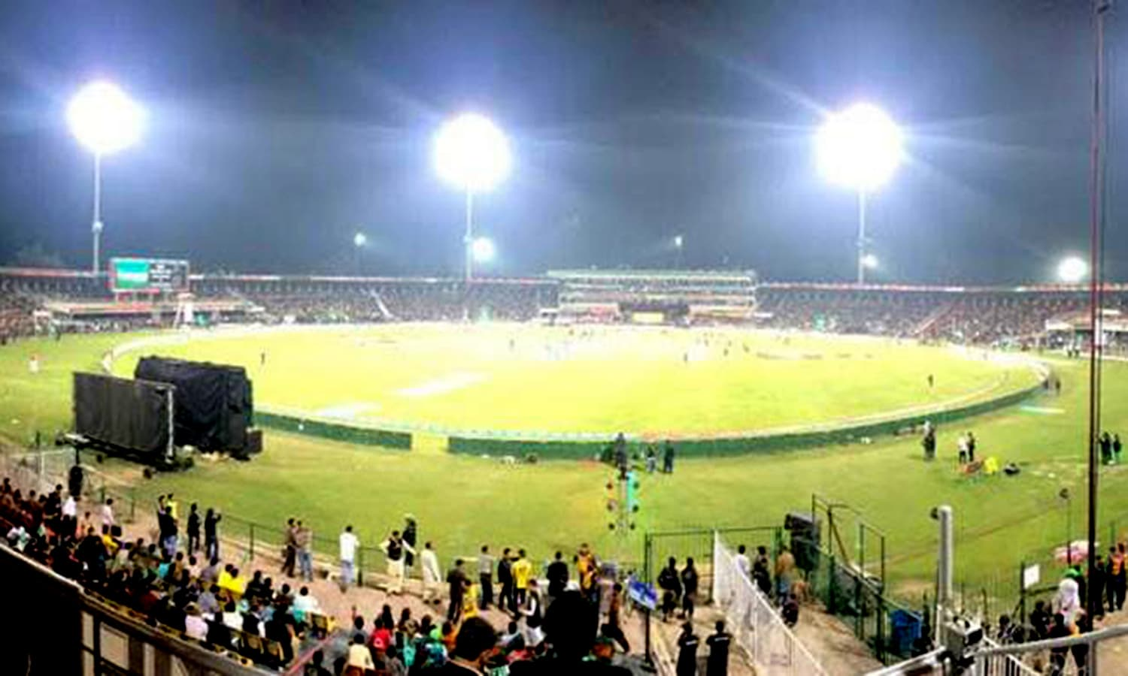

Located in the historical city of Lahore, the Gaddafi Stadium, named after the Libyan leader, was completely renovated during 1995-96 ready for the 1996 World Cup. Designed by the famous architect Nayyar Ali Dada who modelled it on the Mughal School of red hand-laid brickwork and arches, the new stadium is completely covered with plastic seating rather than concrete benches. The lower portion under the stands has been enclosed and converted to shops for boutiques and offices. This was the first stadium in Pakistan to be equipped with modern floodlights which have their own standby power generators. Modern facilities for the media are also provided.

Pakistan have enjoyed some memorable moments on the ground, including a fifth-wicket stand of 281 between Javed Miandad and Asif Iqbal against New Zealand in 1976 and an innings and 324 run win against New Zealand in 2002 The stadium hosted the final of the 1996 World Cup, which was watched by over 60,000 spectators. However, despite the impressive capacity, the ground is often sparsely attended for Test matches, with sometimes as few as 1000 fans turning up. One-day internationals, as with the whole of the subcontinent, are more popular; crowds in excess of 20,000 are common.

**Tomb of Allama Iqbal:**

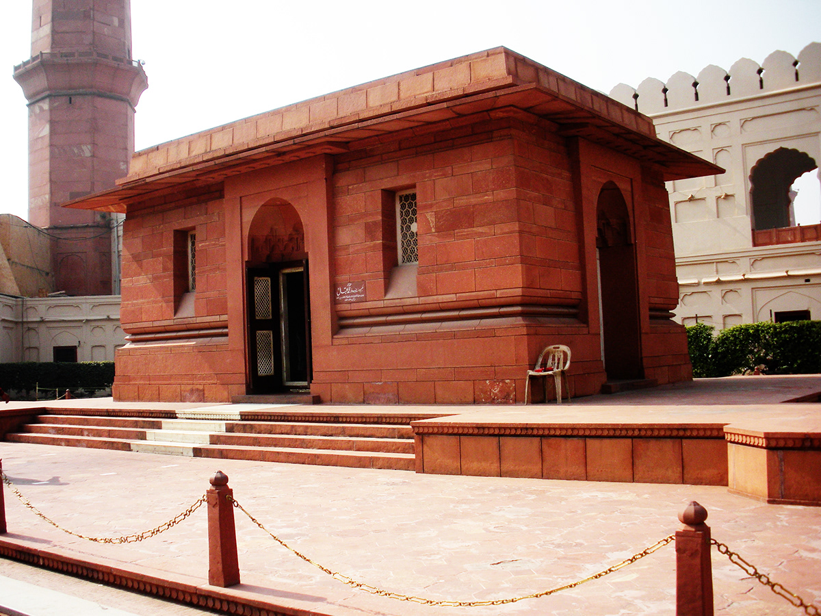

The Tomb of Allama Muhammad Iqbal (The poet of the East and the thinker of Pakistan) is located in Hazuri Bagh, Lahore, Pakistan, just to the left of the main entrance of Badshahi Mosque. The rectangular shaped tomb is made of red sandstones. The architecture reflects a combination of Afghan and Moorish styles. A large number of visitors visit the mausoleum every day to offer Fatiha and pay tributes to Allama Muhammad Iqbal for his services.

**Shalimar Bagh:**

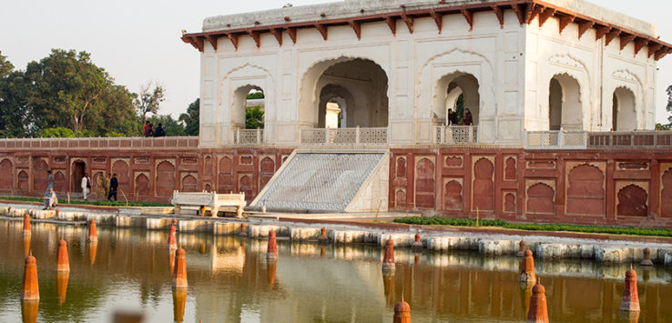

Anyone who wants to see one of the best-preserved Islamic gardens on the planet must plan a trip to Pakistan. The northeastern city of Lahore is full of historical gems from the powerful Mughal Empire. Luckily for the world, the Mughals’ glorious Shalimar Gardens have been spared the ravages of time. The Shalimar Gardens are the finest example of Mughal garden construction that survives to this day.

People who visit this area for the first time are usually impressed with the gardens’ size. In total, these gardens measure around 660 meters by 250 meters. The Shalimar Gardens are in the shape of a rectangle and are composed of three terraces. From the lowest to the highest, the three terraces are named Bestower of Life, Bestower of Goodness, and Bestower of Pleasure.

The construction of these gorgeous gardens dates bakes to 1637 AD. Shah Jahan, the fifth Mughal emperor, ordered these pleasure gardens to be built in the Persian style. In particular, these gardens drew inspiration from the Emperor Jahangir’s Shalimar Gardens in Kashmir, but there are also influences from designs in Delhi Sultanate and Western Punjab. Completed in 1641, the gardens are considered one of the finest examples of Mughal garden construction in the world.

The Shalimar Gardens provide an interesting contrast to the Lahore Fort, which is only seven kilometers away from the gardens. The Lahore Fort commands attention with soaring architecture. The gardens, on the other hand, induce a state of calm in the visitor. But don’t think the gardens took less skill to create than the mighty Lahore Fort. Although the gardens are made to look natural, it took the designers a great deal of effort to arrange the trees and waterfalls such perfect symmetry.

Once you walk into the gardens, you’ll notice that the Shalimar Gardens are designed in a rectilinear fashion. The three main terraces descend from the south to the north of the gardens. The garden designers made sure every tree was balanced out on both sides of the water. Also, notice how the trees reflect in the central flowing water. Just a few of the trees you’ll see as you walk around include cypress, plum, poplar, and gokcha trees.

As you stroll around, be sure to spend extra time looking at the walls that surround these gardens. Art historians say the fretwork on the brick walls is some of the finest in the Islamic world. The Mughal Empire was well known for its floral designs, especially in its grand Badshahi Mosque, and this amazing fretwork is a testament to the Mughals’ aesthetic prowess.

Guests to the Shalimar Gardens often enjoy exploring the historic buildings throughout the three terraces. The Mughals built a few summer pavilions that are extremely comfortable in the summertime. These pavilions take advantage of the cool water and offer a necessary respite from the desert heat. Guests can also take a look at the royal bath and the sleeping chambers and imagine what royals must have relaxed here in the past.

There are literally hundreds of fountains in this garden. Believe it or not, architects study the Mughals’ fountain design to this day for inspiration. Many designers and scientists can’t understand how the Mughals were able to construct such perfect fountains on each of the three terraces. The Mughals allowed the water to cool as it flowed down the three terraces, so the coolest water is on the bottom. This was needed to survive the brutal summers in such an arid climate. In total, there are 410 fountains in the gardens.

**Tomb of Jahangir:**

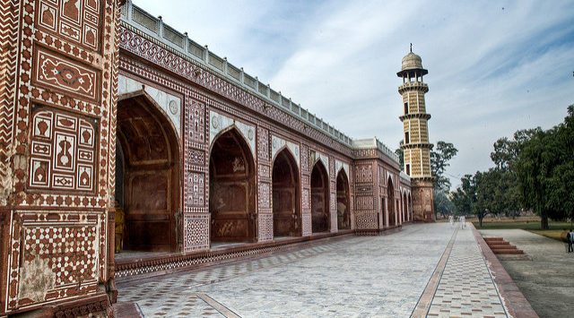

The Jahangir tomb is a mausoleum of “Nur-ud-din Mohammad Salim” who ruled Mughal Empire between 1605 – 1627. With the imperial name of “Jahangir” he was considered to be the one of the greatest Mughal emperor. He has also been known for his illicit romantic love story with Anarkali, which is widely adopted in the literature & cinemas. Akbar, his father nominated him as his successor in the very early age and he ultimately became emperor in 1605.

Jahangir was fascinated with art, science and architecture. He started painting when he was very young and played a vital part in promoting art of Mughal painting in his region. Jahangir died in 1627 on his return from Kashmir & buried in Shahdara baagh, Lahore. Shahrda was a “favorite spot” of Jahangir and his wife “Nur Jahan” when they lived in the city. This garden is known as “Bah-e-Dilkusha” meaning a garden that fills your heart with joy.

Akbari sarai is a series of rooms that was made in the Shahdara Bagh near the Jahangir's tomb for visitors who used to come for visit. It is said, that the doors of Lahore fort were closed after sunset, and the visitors who reach Lahore after the sunset spend their night in the Akbari sarai. The 180 hujra, or cells, around the courtyard were used as living area and storage space for luggage for the visitors. After the Mughal period this sarai has been used by different purposes by Sikh and british rulers.

After the death of Jahangir, his son, Prince Khurram (Shah Jahan) was entitled and become emperor who build a marvelous architecture for his father’s mausoleum. Historians write this was made possible with the vision of “Nur Jahan” wife of Jahangir. It took about 10 years to build the tomb and with the cost of 10 lakh on the site of Bagh-e-Dilkusha. The construction was completed in 1637 AD, which used various stones in building this structure.

The interior is decorated with flowery walls, delicate inlay work, and with stones of various colors. In stones such as Sang-e-Musa, Sang-e-Khattu, and marble etc. are used for inlay work. These inlay motifs are called “Raqam”. On the both sides of the grave ninty-nine (99) names of Allah (God) are also engraved in black. Light enters from big Jali screen, which is facing toward mecca.

Along with restoration and beautification of Jahangir tomb, the construction lake near to tomb, installation of chairlift to ease the public access to the monument and a museum comprising artifacts of Mughal era are the core activates of this restoration project. The mausoleum of Jahangir holds a special place among the architectural relics of Pakistan as it is the only remaining Mughal tomb in the country. Its image appears on the National Currency and it remains Lahore’s most popular attraction.

**Minar -e- Pakistan:**

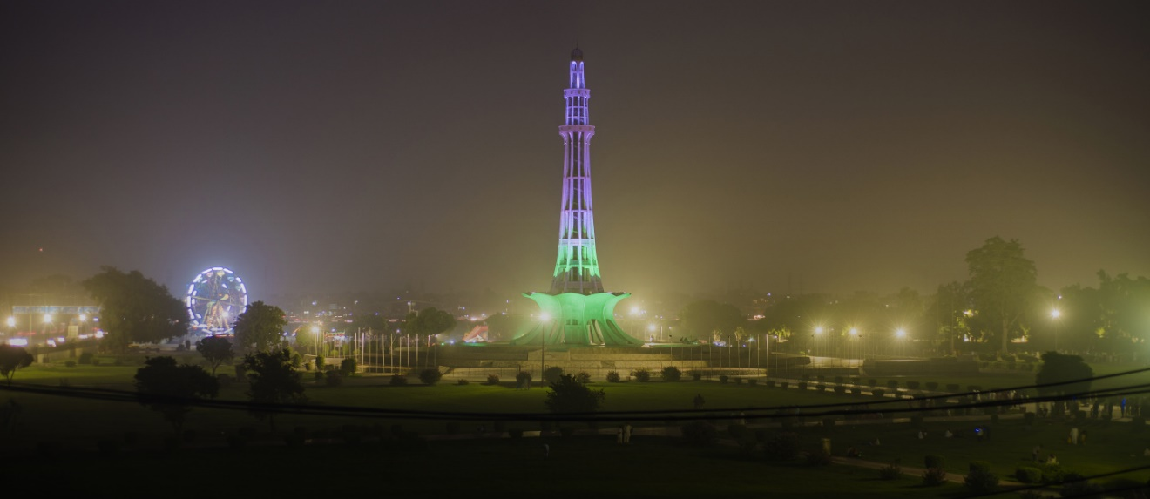

Minar-e-Pakistan is a historical monument in Lahore. It is considered as the largest tower in Pakistan. Minar-e-Pakistan is the place where Lahore resolution was passed which was the official call for a separate homeland for the Muslims of South Asia in the result of two nation theory.

Minar-e-Pakistan which is also known as the “Tower of Pakistan” is an open landmark placed in Iqbal Park in Lahore, Pakistan. The tower was built throughout the 1960s on the site where, on 23 March 1940, the All-India Muslim League passed the Lahore Resolution, the first official call for a differentiate country for the Muslims living in the South Asia, as per the two country theory. The tower reflects a mix of Mughal, Islamic and present day structural engineering. 

The base is in the ballpark of 8 meters above the ground. The tower ascents around the range of 62 meters on the base, along these lines the aggregate stature of minaret is in the vicinity of 92 meters above the ground. The unfolding petals of the bloom like base are 9 meters high. The breadth of the tower is something like 9.75 meters. The platform is constructed of designed tiles, and faces the Badshahi Mosque. The base involves four stages. To symbolise lower beginnings of the flexibility battle, first stage is constructed with uncut Taxila stones, second stage is made of mallet dressed stones, while third stage is of chiselled stones. Cleaned white marble at the fourth and last stage delineates the triumph of the Pakistan Movement. Mr. Mukhtar Masood, a productive author and the then–deputy official of Lahore, was one of the parts of the Building Committee. 

At the base, there are botanical engravings on ten focalizing white marble Commemorative plaques. The engravings incorporate the content of Lahore Resolution in Urdu, Bengali and English, and Delhi Resolution's content, which was passed on 9 April 1946. On diverse plaques, Quranic verses and99 properties of God are engraved in Arabic calligraphy, though National Anthem of Pakistan in Urdu and Bengali, selections from the talks of Muhammad Ali Jinnah, in Urdu, Bengali and English, and also not many couplets of Allama Iqbal are inscribed.   
  
With the development of the city and area of the landmark at occupied convergence of Circular Road and Multan Road, air contamination from movement clogging is ceaselessly harming the marble structure which is presently in need of renovation. Being the verifiable tower of Pakistan and having incredible significance, it is greatly suggested by the designers that the building needs repair any other way it. Minar-e-Pakistan is considered as the national building of Pakistan. Many of the tourists from the whole world prefer to visit this historical monument.

**Wazir Khan Mosque:**

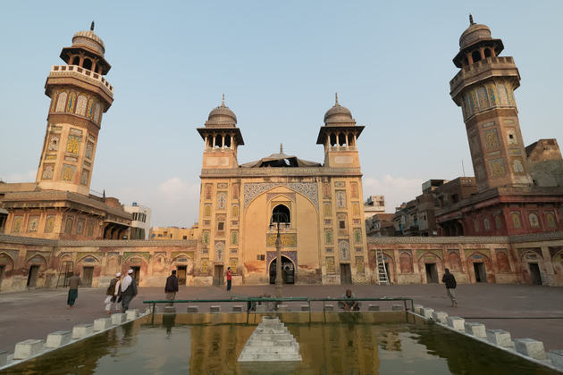

Wazir Khan mosque was built in 1634 by Shaikh Ilm-ud-din Ansari, Viceroy of Punjab under Shah Jahan. Ansari hailed from humble origins in the town of Chiniot in the Jhang district of the Punjab. He studied medicine under Hakim Dawi and was hired by the Mughal court as the personal physician of Prince Kuram, the future Shah Jehan. The young prince was so taken with Ansari's competence that he awarded him with the title Wazir Khan in 1620. Wazir is a title meaning "Minister" in Urdu.

Wazir Khan acquired a large tract of land in Lahore bounded by the Delhi Gate to the east and the Lahore Fort to the west. He founded the mosque that now bears his name on the site of the tomb of Syed Muhammed Ishaq (also known as Miran Badshah), a saint who had migrated from Iran in the 13th century. Wazir Khan also established a bathhouse (Shahi Hammam) and other commercial establishments along the road to the mosque whose income was intended to ensure maintenance of the mosque into perpetuity. Although the bathhouse did not provide as much income as intended, the bazaar to the east of the mosque was quite successful and remains a flourishing market even to the present day.

The mosque's distinguishing architectural feature is the use of minarets at each of its four corners--the first time such a design was employed in Lahore. The prayer hall follows the one-aisle five-bay motif that was first established in Lahore a generation earlier at the Maryam Zamani Mosque, which was later to find its full expression in the Badshahi Mosque built by Emperor Aurangzeb a half century later. Much of the mosque is constructed of cut and dressed brick decorated with glazed tile mosaics.

A curious feature of the mosque is the incorporation of 22 shops into its ground plan. Situated on either side of the entrance hall, these shops form a bazaar with a brick-paved passage in between. This commercial area extends east beyond the mosque into the Chowk Wazir Khan (Wazir Khan Square) which remains a vibrant commerical district to the present day.

**Fortress Stadium:**

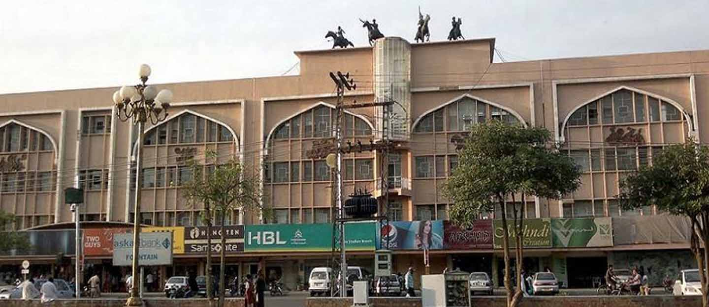

Located in Lahore’s Cantonment Area on Aziz Bhatti Road, Fortress Stadium, Lahore, is a grand sports ground with plenty of outdoor space for recreation and commercial opportunities. While the stadium is now rarely used, except for occasional cultural and sporting events, very little else has changed. It is still a busy commercial hub of the city. Here’s all you need to know about Fortress Stadium, Lahore.

With the construction of the Fortress Square Mall in its immediate surroundings in 2014, and the stadium being out of use, for the most part, the premises of Fortress Stadium are now known only as Fortress to the locals. The area has become a hub of family entertainment for the locals, as the mall offers plenty of shopping opportunities at high-end brands, while kids can enjoy themselves at Joyland, Sindbad, or St. John Park, Lahore, at a walking distance from one another.

The stadium itself is used for the National Horse and Cattle Show, which is a popular festival in Lahore, along with hosting cultural events, fairs, and local sporting events. The ‘National Horse and Cattle Show’ displays livestock, along with spectacular displays of horsemanship, racing, folk dancing, and much more.

The open premises outside the stadium contain shops, cafés, and restaurants, making it a commercial and entertainment hub. It is also one of the busiest commercial districts in Lahore. The major facilities and entertainment options at Fortress Stadium, Lahore, include:

* Fortress Square Mall
* Joyland Amusement Park
* St. John Park
* Sindbad’s Wonderland

**Data Darbar Shrine:**

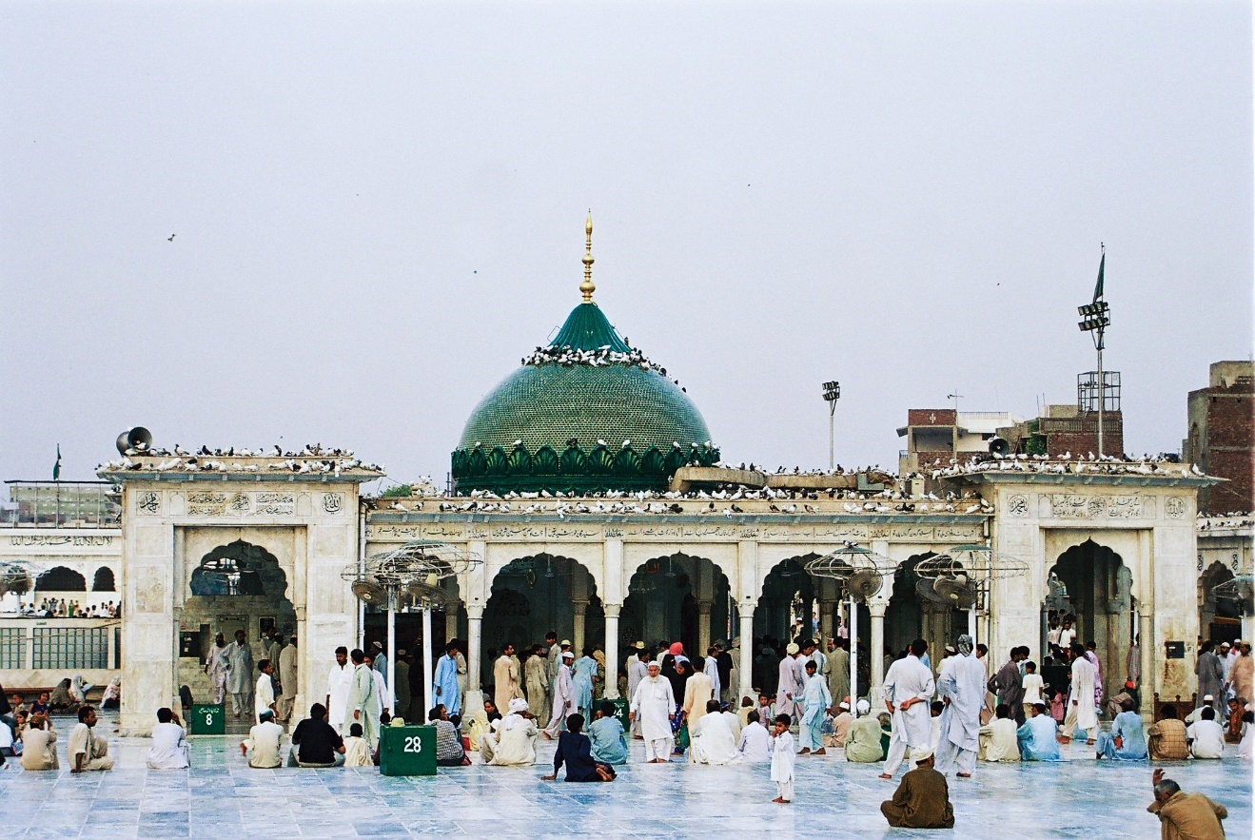

Data Darbar is one of the oldest Muslim shrines on the subcontinent.

It houses the remains of a Sufi saint, Abul Hassan Ali Hajvery. He is said to have lived on the site in the 11th Century.

He is one of the most well known and revered of the subcontinent's Muslim saints.

Reputed to have miraculous powers, he was an erudite scholar with several books to his credit.

Most are in publication today and have been translated into dozens of languages including English.

For centuries his tomb was visited by Muslims and Hindus in search of his blessings but since partition, most visitors have been Muslim, although people of all religions are welcome.

Pakistan's main opposition leader Nawaz Sharif is a frequent visitor.

The shrine is located near the Bha'tee Gate into Lahore's Walled City.

It was originally built by the Ghaznavi king Sultan Zakiruddin Ibrahim later in the 11th Century and has been expanded several times since.

**Grand Jamia Mosque:**

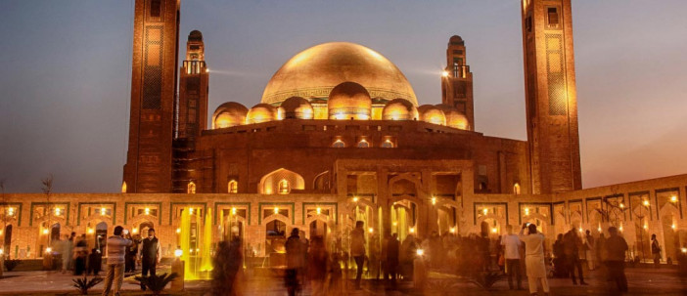

Grand Jamia Mosque is a mosque located in Bahria Town, Lahore, Pakistan which is the largest mosque in the country by covered prayer facility and is 7th largest mosque in the World.

The base of the entire structure is elevated 20 feet above the ground, with the rooftop elevating to 80 feet and the Grand Dome placed in the center surrounded by 20 smaller domes. Marking the extremities of the entire structure are the towering minarets standing 165 feet tall. The mosque include's 6 arched shape wooden doors and then dazzles you with views of white chandeliers, tile-mosaic and frescos of extraordinary beauty. The Center Dome is the crown jewel of this magnificent piece of craftsmanship. Rising 40 ft. in height and spreading 50 ft. The indigenous Architecture is woven in entirely local materials, reflecting the true essence of Indo-Islamic architecture with a rich blend of modern elements. The main structure is created from “Brick Gutka” made of special “Multani Mitti” to avoid saltpeter commonly found in Lahore Bricks. the brick structure has been extensively decorated with vibrant colored glazed tile mosaic art, displayed in geometrical shapes and floral patterns.it was designed to be an architectural wonder in 6.6 million that incorporated both modern and classic Islamic artistic styles. Greek and Italian white marble covers the exterior, while Islamic calligraphy decorates the inside. 4.5 million handmade ceramic tiles were hand placed by the craftsmen, which alone took 4 years. The octagonal shaped minarets stand majestically tall at 165 ft. and are a beautiful exhibit of craftsmanship. The base of each minaret has 4 arch shaped wooden doors decorated with extensive mosaic art in vibrant colors that ascend all the way to the top of the structure. Each minaret has wooden balconies made from “Sheesham” and the rooftops are cupola shaped canopies.

**Jallo Park:**

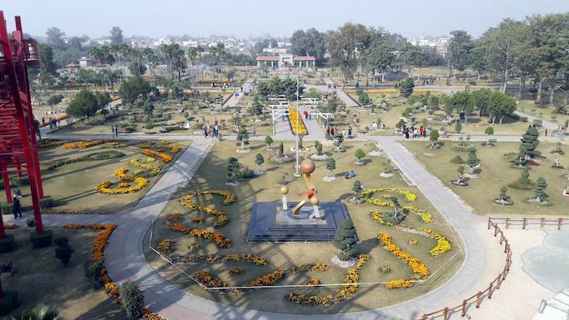

Jallo Park easily qualifies as one of the [best places for family picnics in Lahore](https://www.zameen.com/blog/best-picnic-places-lahore.html). If you love nature, then this place should be on your bucket list. As discussed, this park features an excellent mix of exotic wildlife including birds, insects, and other animals.

This botanical garden in Lahore is among the best places you can visit with your kids as it has a lot to offer in terms of information about plants and animals. You can also show them the diverse wildlife, their life cycle, and habitat. Located about 20 km east of Lahore, the park was originally founded in 1978.

From 2007 to 2010, the site was developed and expanded under a government scheme. After the successful execution of the project, the park became one of the top spots to visit in Lahore.

Jallo Park spreads over an area of 461 acres, so please wear comfortable shoes if you’re planning to visit. Those who aren’t fond of walking can make use of rickshaws available within the park that can help you get around easily from one place to the other.

One of the major attractions of this botanical garden in Lahore is the butterfly house – home to 3000 species of butterflies. The concept of the butterfly house was proposed by Iftikhar Ahmed, Vice Chairman of Park and Horticulture Authority (PHA) Lahore. According to the officials, it is Pakistan’s first-ever butterfly house that serves as the source of education and entertainment for the citizens.

The management has put procedures in place to maintain artificial humidity in the butterfly house as butterflies can’t survive high temperatures.

The butterfly house also comprises an interpretation gallery, where you can learn more about butterflies, a butterfly tunnel, waterfalls, a stream, a collection of larvae, a rearing chamber, an aquarium, and a souvenir shop.

Jallo Park – one of the most [beautiful parks in Lahore](https://www.zameen.com/blog/famous-parks-lahore.html) – is located on [Jallo Road](https://www.zameen.com/area-guides/jallo-park-road-lahore/) which connects to the [Canal Road](https://www.zameen.com/area-guides/main-canal-bank-road-lahore/) at a later point. It is situated in close proximity to [Grand Trunk Road](https://www.zameen.com/area-guides/gt-road-lahore/) and [Lahore Ring Road](https://www.zameen.com/area-guides/ring-road-lahore/). Barki Road stretches to the south of this botanical garden. Some nearby attractions are Sky Land Water Park, [Sozo Water Park](https://www.zameen.com/blog/sozo-water-park-lahore-family-fun-destination.html" \t "_blank), and [Shalimar Gardens](https://www.zameen.com/blog/shalimar-gardens-lahore.html). Meanwhile, [Allama Iqbal International Airport](https://www.zameen.com/blog/allama-iqbal-airport-lahore-guide.html) is located at a 30-minute drive from here.

**Moti Masjid:**

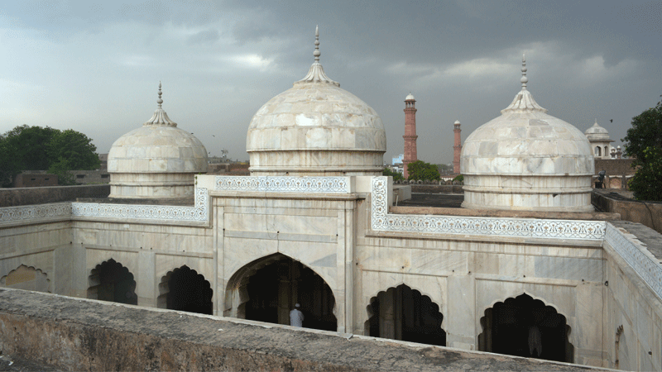

The Moti Masjid, or Pearl Mosque, is a relatively small structure located at the western side of the fort. It is built entirely of white marble mined from the town of Makrana in contemporary Rajasthan. The mosque is one of the few buildings inside the fort that deviate from the overall north-south orientation of the complex, satisfying the liturgical requirement that the mosque's mihrab (central niche) face directly toward Mecca.

As is the case with many mosques, the outward appearance of the Moti Masjid is dull and unpretentious. It can only be accessed through a small door at the northeast located near the Makatib Khana. The mosque's antechamber is long and dimly lit, creating a sense of enclosure which is suddenly relieved when the visitor crosses the threshold into the mosque's courtyard. All at once, the visitor is confronted with a brightly lit panorama of gleaming marble that visibly proclaims the purity of the mosque in direct contrast to the world that surrounds it.

The facade of the Moti Masjid is divided into five bays with the central bay protruding slightly forward into the courtyard. The five bay facade was a favored Mughal motif that was first seen at the Maryam Zamani Mosque and subsequently employed at most major Mughal mosques. The Moti Masjid differs from the Maryam Zamani precident in the inclusion of two transverse aisles along the western wall instead of one.

Lahore's Moti Masjid was not the only "Pearl Mosque" built in the Mughal era. Mosques with the same name may also be found in Agra and Delhi, as it was common Mughal practice to name mosques after precious stones. The word "Pearl" also refers to the lustrous surface of the marble, resembling pearl, as well as the mosque's comparatively small size.

**Delhi Gate:**

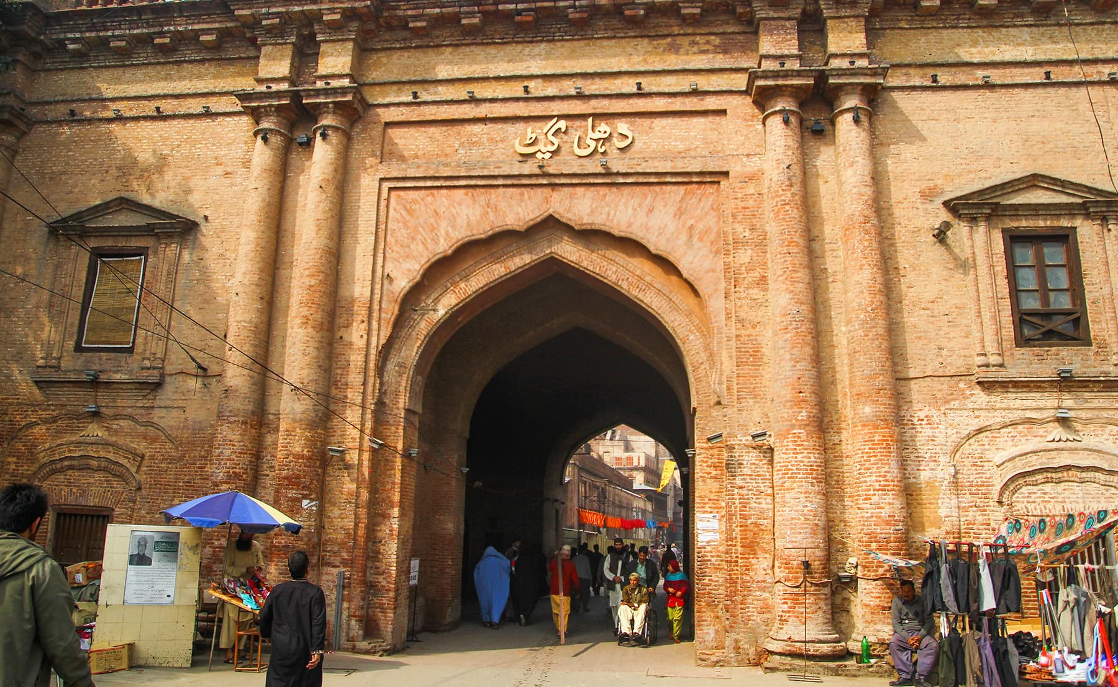

Delhi Gate (Delhi Darwaza) is one of six remaining historic gates of the [Walled City of Lahore](https://en.wikipedia.org/wiki/Walled_City_of_Lahore), [Pakistan](https://en.wikipedia.org/wiki/Pakistan). Delhi Gate and the adjacent [Shahi Hammam](https://en.wikipedia.org/wiki/Shahi_Hammam) were restored in 2015 by the [Aga Khan Cultural Service Pakistan](https://en.wikipedia.org/wiki/Aga_Khan_Development_Network).

Delhi Gate was the most important of all the gates because the Mughals used it while travelling from Delhi to Lahore Fort. That is why the straight passage leading to Lahore Fort from this gate came to be known as ‘Royal Trail’ or Shahi Guzargah. Now imagine the past glory coupled with this gate, the royal guards standing at the gate, Mughal entourages passing through the streets and people leaning over the balconies and jharokas to take a glimpse of their royals, kings and queens and showering flowers.

This gate is huge among the six surviving gates of Lahore. It is a double storey building and almost ten to twelve rooms are serving as class rooms in the upper portion. The most interesting part of the building is the staircase leading to the roof top of the gate. The stairs are built at an angle of 90 degrees and it is difficult to climb them in a speed as one loses the momentum. This was in order to protect the building from sudden attacks and reduce the attackers speed and it shows the cleverness and techniques of defence employed in those days. Going to the upper storey, one can see the roof of the Royal Bath (Shahi Hammam) on the left side. The roof of the gate is even, which gives a spectacular view of the old city and Delhi Gate’s vivacious bazaar. The colors of life are in the air if you ever reach its rooftop. The ground floor of the gate which is the entrance into the Delhi Gate bazaar has six rooms which are now converted into tourism offices and crafts centre. These rooms were used by the chobdars in Mughal era, magistrate and police in later eras. For some time after 1947, the rooms served as dispensary and health centers for the local community.

This gate was conserved in a conservation plan by the Walled City of Lahore Authority in 2015 and has now been illuminated at night for the tourists. If you ever plan to visit this place, there is a tourism information center inside the gate and you can get hold of a good tourist guide from there, any time. In my opinion it’s a must visit heritage site in Lahore.

**Wahga Border:**

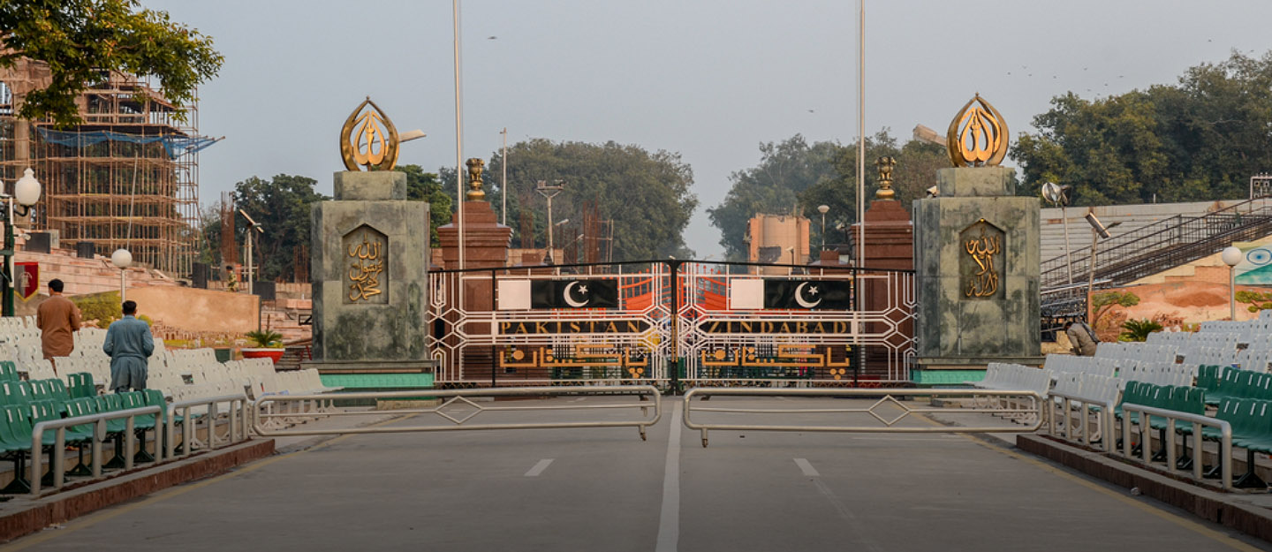

The Wagah Border is located some 27 kilometres from Lahore.

Depending on your location and the traffic situation, it takes about 40 to 50 minutes to reach the Wagah border crossing through Grand Trunk Road.

You simply cannot visit the City of Gardens and miss out on attending the spectacular military parade at the Wagah Border. Dating back to 1959, the traditional flag-hoisting and lowering ceremonies take place every morning and evening at the Pakistan-India border, which is considered one of the [most popular tourist attractions in Lahore](https://www.zameen.com/blog/top-10-amazing-places-visit-lahore.html). However, it’s the Beating Retreat Drill held before the sunset that draws a large number of people every day.

The event is witnessed by hundreds of men, women and children chanting patriotic slogans on both sides of the Wagah Border crossing. Therefore, whether you are visiting this historical city for work or leisure, you should definitely take some time out to witness the famous military demonstration at the Wagah Border in Lahore.

But before we delve into the location of Wagah Border, its nearby attractions and discuss the timings of the ceremony, let’s first talk about the border itself and what the drill represents.

The Wagah-Attari border is situated on the road between Lahore and Amritsar. It is the only open-land border crossing between India and Pakistan. A majority of goods transported between the two countries also go through this point.

As for the Wagah border ceremony, it is carried out by the officers of Pakistan Rangers who march in front of a large crowd with patriotic songs playing in the background.

However, itis much more than a show of pomp and bravado. While the parade is highly entertaining and invokes feelings of patriotism among those in attendance, the ceremony actually symbolizes both the rivalry and camaraderie between the two nations, as soldiers from both countries give each other a handshake before formally closing the border gate following the flag-lowering ceremony.

The impressive parade also reminds the civilians of the sacrifices made by the military to safeguard the sovereignty of our country.

Needless to say, every Pakistani must visit the historic Wagah Border in Lahore at least once in their lifetime. In fact, even if you only have [24 hours to spend in Lahore](https://www.zameen.com/blog/things-to-do-lahore-24-hours.html), you need to add this activity into your itinerary.

**Food Street Fort Road:**

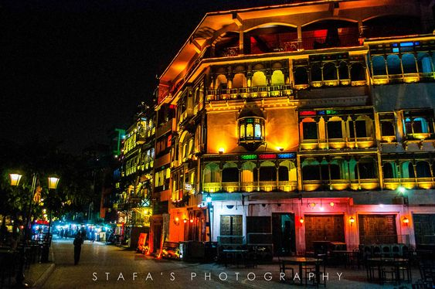

The old Food Street of Lahore also known as Fort Road Food Street has several attractions for tourists of different tastes.

Besides the availability of different cuisines available, the food street is located in the walled inner city of Lahore which is an architectural marvel itself. The building that the street is based on was built back in the era of the Mughal Empire and the British Rule. The buildings are flat and tall, they have been kept as the symbol of history and the colors are maintained in the same manner. Buildings are in vibrant colors and every building has a different color to the ones next to it. The walled city Lahore can be said as encapsulated by a wall all around and the food street is based in the middle of the Fort Road and Roshnai gate.

The street is very crowded and people prefer to either travel by bike or rickshaw (Three Wheelers) so that they do not get stuck in the traffic or reach their destination accordingly. Food Street has unique buildings that still have wooden fences in front of the balconies and windows, they are the old-styled building which can rarely be seen in places in the world. There are several art pieces and paintings that are on display in these restaurants, these vary from calligraphy to portraits to abstract art as well. Some of the restaurants are so old that they have images of the rulers visiting these places and enjoying their meals, they have a maintained guest list of all royal and noble people who had visited them. The stairs used in the building to get from one floor to another are not made from brick or concrete rather they still have the wooden stairs maintained which tend to create a feeling of architecture from the past.

A good amount of plants and trees have been planted near to sidewalk to make the architecture look more beautiful, the structure of the windows and balconies is similar to what you may see in a movie depicting the history of the region. At night time, the food street is lit with lights of different colors that make it look like a market from the past. Different kinds of entertainers come to the food street as well, some people exhibit local dances in historical dresses, different people singing folklore for the history of the region, and even some fire-spitting artists that create an attraction for tourists. The best part of this food street is that it all relates to the history of the area, and these activities are the same as they were back in the time.

**Sozo Waterpark:**

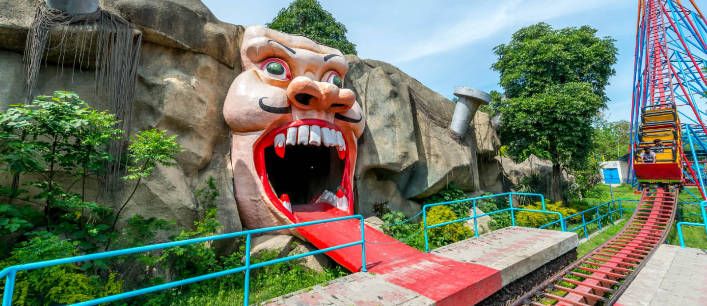

Sozo Water Parks gives an exciting, fun place to the customers. Because exciting and thrilling rides engage its visitors. Adventurous places always create a thirst for daring people.

This park offers separate sections for men and women. Also, in each area, there are two pools, one for non-swimmers or kids. The water level is not much in the kid’s section. So, the people who don’t know how to swim can go tothe kid’s area.

Some slides seem interesting to fearless people as there is a separate pool for kids, so their slides are different from the adults. For protecting children from injuries or any accident, the park has taken this step.

Along with the water slides, there also exist other rides. Rides else for water slides also give so much fun and joy to the visitors. So, people who don’t like to swim can also consider this place for having fun.

A person can also choose this park for picnics. For school and family picnics, Sozo Water Park can be a very great choice as there are too many fun activities at a very reasonable price range.

One of the major things that people usually pay attention to while visiting water parks in Lahore is cleanliness. According to the Sozo Water Park’s official website, pools and activities areas containing water in Sozo Water Park are effectively treated with chemicals. This chemical treatment keeps bacteria and germs from surviving in the water.

Moreover, the water is changed and filtered every now and then using silica and rocks to remove every possible trace of dirt and solid waste. Water beds in the park are cleaned with the help of robots imported from the United Kingdom, according to the management.

Make a plan to this park and enjoy an exciting day with people you love.

**Alamgiri Gate:**

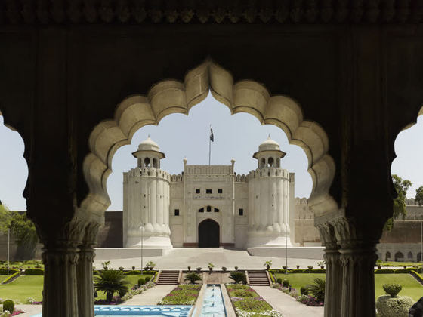

The Alamgiri Gate is the only major addition to the fort built by Emperor Aurangzeb. It was likely constructed at the same time as the Badshahi Masjid which it faces. The gate is noted for its heavily fluted bastions crowned with domed pavilions.

The Alamgiri Darwaza, or Alamgiri Gate, was built under the patronage of Awrangzib (1658-1707). It is situated on the eastern edge of the Lahore Fort, and leads by way of a sharply angled passage, to the large courtyard of the Diwan-i-Amm, the most public area of the fort's administrative areas. The gate is characterized by what some have called a 'softening' of the Mughal style in its later years: the fluted towers flanking it rise out of carved lotus buds, and are topped by small kiosks.

**Anarkali Bazar:**

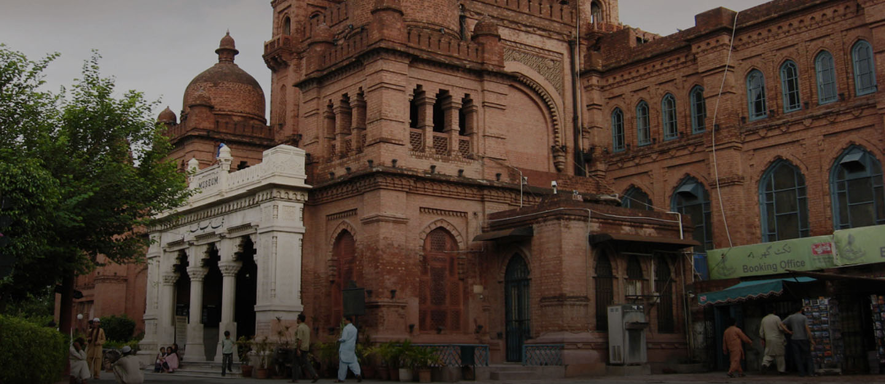

Dating back to 200 years ago, Anarkali is not only famous for its bazaar but it is also a union council in the neighbourhood of Data Gunj Buksh Tehsil. It is a busy area filled with the hustle and bustle of shoppers, sellers and by-passers. Many come to enjoy the atmosphere and the beautiful architecture of its colourful bazaar.

Anarkali is named after a famous courtesan during the rule of Mughal Emperor Akbar.  According to mainstream historical reports, Anarkali, much to Akbar’s dismay, allegedly seduced Akbar’s favourite son and heir, Jahangir. On Akbar’s decree, she was either stoned in the wall or chased out of the city as per different historical perspectives. Her mausoleum is located near Anarkali Market.

The market has two sections namely Old Anarkali Bazaar and New Anarkali Bazaar. While the former is popular for shops of traditional desi cuisine, people visit the latter for embroidery, jewellery, textile and handicrafts. It has three main markets, Dhoni Ram Lane, Bano Bazaar and Paan Gali.

Anarkali is, in fact, a historically significant area of Lahore. Several monuments and landmarks are located in and near Anarkali, including Lahore Museum, Tomb of Anarkali, Sultan Qutb ud-Din Aibak mausoleum, Shahi Hamaam and Javed Manzil.

Anarkali connects with several busy routes of the city including Katcheri Road, Circular Road and Crust Road. It also touches Mozang Road while Mall Road passes through this market. The shrine of the famous Sufi Saint Hazrat Ali Hajveri, lovingly called Data Gunj Baksh by his disciples and followers, is a short walk from Anarkali.

Moreover, some of Lahore's most famous educational institutes are located in the vicinity. There is National College of Arts (NCA) – one of the Pakistan’s best arts institutes, Government College University (GCU) and King Edward Medical University (KEMU).

**Safari Zoo Lahore:**

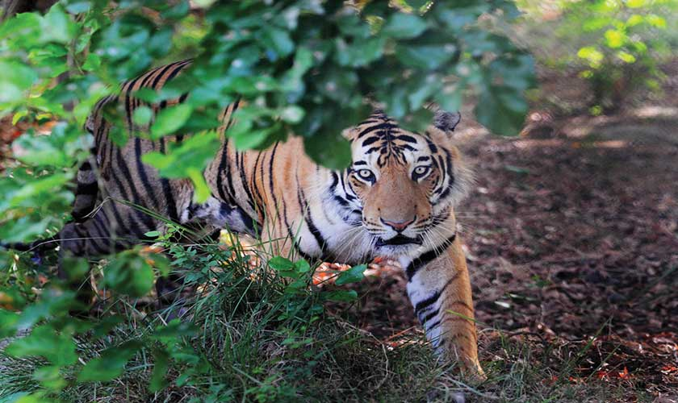

As many as 600,000 people visit the Lahore Safari Zoo to witness its popular lion safari. The distinguishing feature of the attraction rests with its 35 subspecies of African lions.

The safari located on main Raiwand road has 35 lions of African descent brought in 1982 whereas Royal Bengal Tiger, cheetah and puma have also been kept in the zoo.

The Safari Zoo is not like other typical zoos that we had visited before. It is something entirely new and unique and the first experience will definitely leave you amazed.

The Lahore Zoo Safari, formerly the Woodland Wildlife Park, was established in 1982 over an area of 242 acres. The funds for the public facility were provided by the government. Later in 1998, it was handed over to the Punjab Wildlife and Parks Department by the forest department.  
  
The wildlife department officials soon came up with a plan. In 2004, the largest walkthrough aviary of Pakistan was constructed in the facility and was opened for visitors. In addition, other facilities like boating and fishing were also built near a lake in the park’s premises. The lake is the biggest in the city and consists of four islands.

In 2006, the Government of Pakistan sanctioned Rs87 million to reconstruct a two- kilometer long road leading to the wildlife park to make it more accessible for commuters and visitors. There are also safari tracks in the lion and Bengal tiger areas, covering an area of 80 acre.  
  
On January 21, 2009, the park was extensively renovated and renamed the Lahore Zoo Safari. The wildlife park is now considered to be an extension of Lahore Zoo that is situated in the centre of the city.

**Kashmiri Gate:**

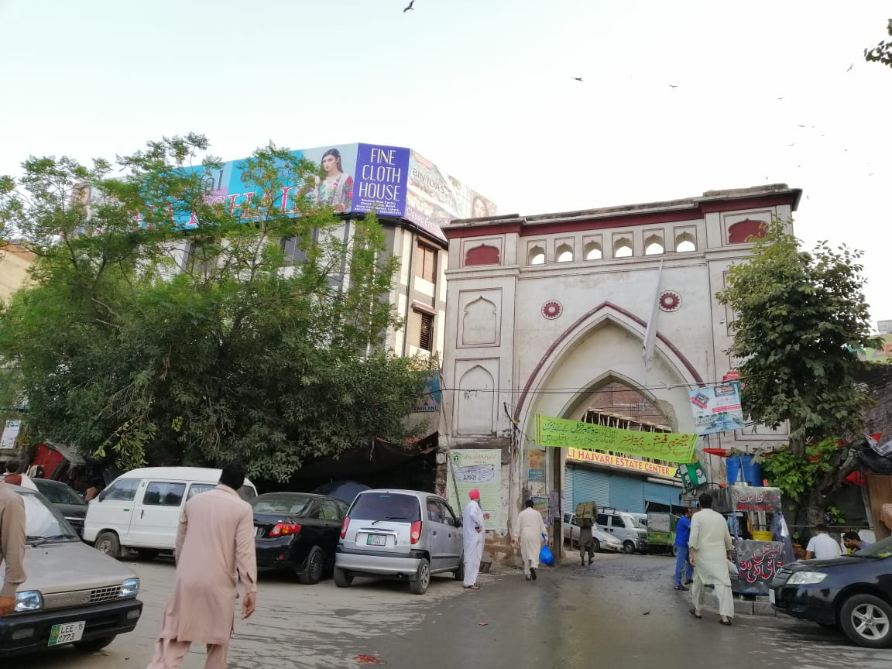

Kashmiri Gate (Kashmiri Darwaza) is one of the thirteen gates of Walled City of Lahore in Lahore, Punjab, Pakistan. The gate gets its name as it faces in the direction of Kashmir.

Inside there is a shopping area and market that is called "Kashmiri Bazaar" where most famously children’s shoes are sold with other different products. And a college, built upon an old haveli belonging to a Shah, is a beautiful example of Mughal architecture.

On your visit to Lahore don’t forget to make a plan of this ancient gate.

**TAXILA**

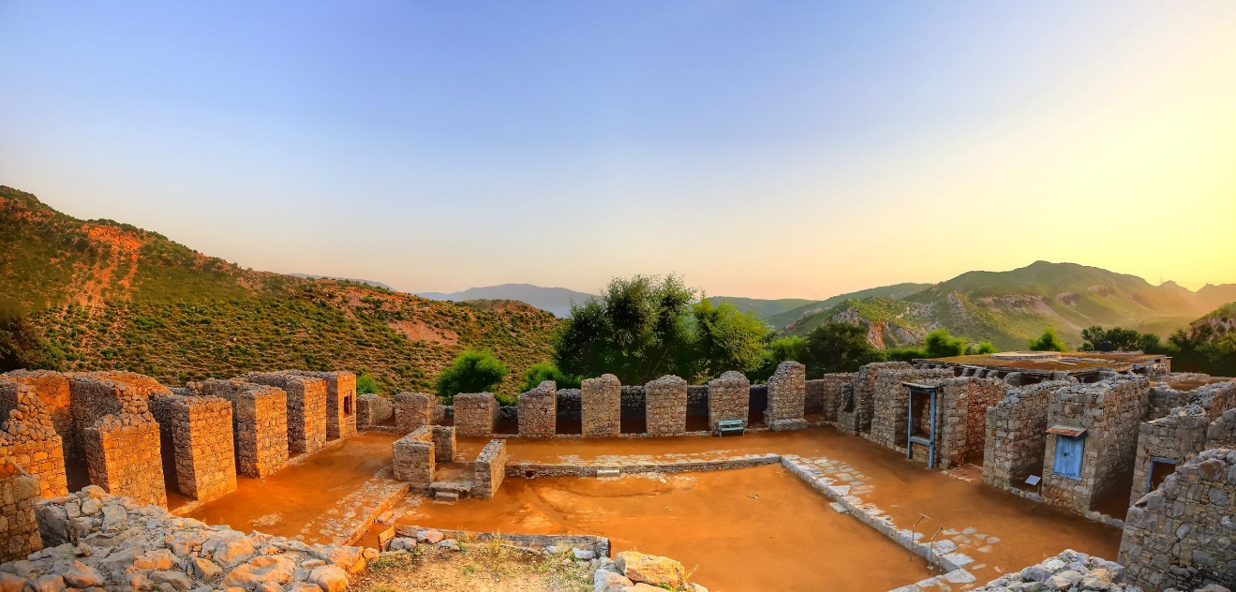

Taxila Pakistan is one of the seven tehsils of Rawalpindi district. Taxila’s historical name is Takshashila, and it is one of the World Heritage Sites in Pakistan. Taxila is a city of Gandharan civilization and was also one of its capitals. It was the most prosperous city of ancient times due to its position at the junction of three main trade routes. The first one was from Eastern India, the second from western Asia, and the third from Kashmir and Central Asia. When the city’s importance declined, the Huns destroyed it in the 5th century CE.

Taxila is situated about 30 km west of Islamabad. Its ruins are approximately 35 km northwest of Rawalpindi/Islamabad. Moreover, Hasanabdal, Khanpur, and Wah are its neighboring cities. Also, Taxila and Wah Cantt are twin cities too. UNESCO declared modern Taxila and its ruins as a whole a[World Heritage Site](https://www.britannica.com/topic/World-Heritage-site" \t "_blank) in 1980.

The origin of Taxila traces back to almost the 5th century BC in the Khanpur caves. The recorded history of Taxila started from the 6th Century BC when this Gandharan civilization became part of Persia’s Achaemenid Empire. Taxila was well known for being the hub of Buddhism in the country. It was also a renowned center of learning and a meeting point of various cultures.

### **1- Bhir Mound**

Firstly, Bhir Mound was the earliest city that dates back to the 6th century. The streets and houses had irregular patterns.

### **2- Sirkap**

The second city was Sirkap, and it dates from the Indo-Greek period. It was built in the second century and was a well-planned city.

### **3- Sirsukh**

The third city was much more modern as compared to the first two. [Kushan Kings](https://www.britannica.com/topic/Kushan-dynasty) built it in the 4th century and was a well laid out city.

Taxila is one of the oldest archeological sites in the world. Statues of leading people such as the great ruler Asoka and [Alexander the Great](https://www.yahyaamjad.com/blog/alexander-the-great-king-of-macedonia/) are discovered in the city. Moreover, many Buddha statues portray various stages of his life that have been excavated and moved to the Taxila museum and at other stupas in the city. There are endless images of a great Saint Gautama Buddha in stone and stucco. However, some of the significant statues have been taken overseas and placed in museums in different countries.

Many [stupas](https://www.ancient.eu/stupa/)represent the peak of Buddhist architectural achievement in the region. Some of the most prominent stupas are:

* Dharmarajika Stupa
* Kunala Stupa
* Jaulian Stupa

Taxila is the most significant tourist attraction in Pakistan. It attracts tourists from all over the world, especially from China and Greece. Also, Buddhists from all over the globe visit Taxila because it was the center of Buddhism.

There is a Taxila museum, which has many things that belong to that period, including the statues. It has a significant collection of stone and stucco sculptures. Museum also has a considerable collection of Gandharan artifacts dating from the 1st to 7th centuries.

Lastly, Taxila Pakistan is an important archaeological site in the modern city of the same name in Punjab, Pakistan. However, to conserve heritage sites in Pakistan, the government need to take strong measures for the maintenance.

**Taxila Museum:**

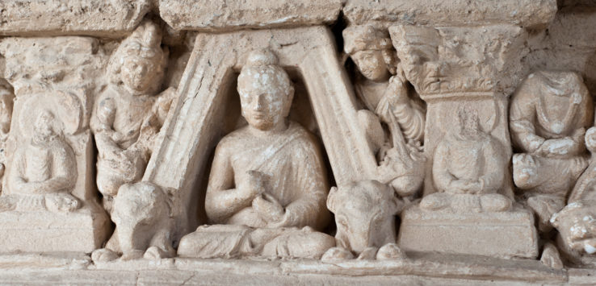

Taxila Museum is a site museum in so far as all the material exhibited here have been excavated in the different sites of Taxila. The museum was designed in the Greek style and galleries were set up by Sir John marshall, the diretor General of Archaeology in British India.

In the six galleries of the museum the material has been presented subject wise. Original objects have been exhibited in the wall showcases and in the middle of the halls are table showcases. The present museum building is only one-fourth of the original plan. The remaining parts are yet to be completed.

As we enter, we come to the main big hall, which shows in its middle a complete stupa from the Buddhist monastery of Mohra Moradu. To its left is an archaeological map of Taxila. On its right and left are table showcases exhibiting small finds. If we turn behind and look at the wall show cases we see schist stone sculptures on two sides. They present scenes from the life of the Buddha, other Buddhisattvas, and examples of Gandhara Art. Inone corner are red sand stone sculptures, and on the other wall are two sandstone sculptures, one of a Budhisattva and another of a Suri-god.

In the next hall to the left are stucco sculptures from Mohra Moradan in the wall showcases. To the left is Buddhist sculptures brought from Jaulian monastery. On the floor are are glazed tiles of the Kushana period.

In the third hall on this side we have stucco heads on the hall showcases. The heads show different faces and hairstyles. The big Buddha heads are typically Gandharan in style. In the middle of the hall area stupa within railing, some relic caskets, and a sleeping Buddha from Bhamala monastery.

As we trace our steps back to the main hall, we can enter a small fourth hall, which shows silver and gold jewelry and coins of the local kings. The gold jewellery presents foreign as well as local styles.

We can again retrace our steps to the main hall and proceed to the right to the fifth small hall. The first important object is an Aramaic inscription of King Piyadasi Asoka. Then we see a series of inscription written in Kharoshthi and also in Brahmi on paper. Then we see small terracotta figurines and a small terra cotta ceremonial tank model. On the opposite well we see iron objects; arrowheads, nails, horsestrips and plough.

Finally we enter the last sixth hall, where, on the wall showcases we see silver glasses of different shapes, bowls and spoons, toilet trays, small pottery pieces, bowls and plates of terracotta and pottery arranged for distillation. On the floor are big storage jars, pestle and mortar and saddle querns.

Anyone visiting the city of Taxila must make a stop at this incredible museum. Just note, this museum is closed on the first Monday of every month and it closes early during Ramadan. Standard hours for this museum are between 8:00AM to 5:30PM.

**Sirkap Remains:**

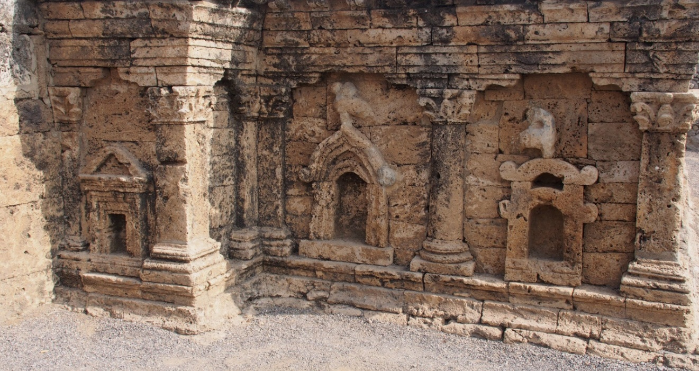

About 30km northwest of Islamabad, the Taxila ruins are located at the eastern edge of an area that once flourished in Ghandara art (Buddhist visual art). Taxila is a group of archeological sites, stupas, monasteries etc. but among them, Sirkap city archeological site is an important area which is a must-visit for all tourists.

In the 2nd century BC, the city was built by Bactrian Greeks (Indo-Greek) who flourished in northern Afghanistan. The ruins of the town are located off of the main street and they spread out in a grid pattern, the foundations of the shops, Buddhist temples and Buddhist pagodas endure.

Ghandara stood in a cultural intersection where it received the cultural influence of India from the east and the cultural inspirations from Greece and Persia (Iran) from the west. The iconic buildings that symbolize that remains in Sirkap.

This is the “Double-Headed Eagle Stupa” that remains in Sirkap. There are three panels separated by Corinthian wall columns with shoots of Acanthus decorations on the wall of either side of the stairs in front of the square platform.

The beautifully preserved panels just to the right of the stairs.

In the panel on the very left, the Greek temple style building with the triangular gables.  
Decorating the central panel is a double-headed eagle-like bird perched on top of an arched building shaped like the entrance to the Indian Chaitya Temple. The double-headed eagle is a design often found in Western Asia such as in Hittite and Babylonia.  
On the rightmost panel is an Indian Torana (like the Indian Sanchi stupas) with a bird-like figure on top of it.

The Taxila Double-Headed Eagle Stupa is a structure that captures your imagination, blending the architectural artistry of India, Greece and Western Asia.

An aerial view of Sirkap, taken by drone, shows a large circular building foundation on the left side of the main street. It is said that it is the remains of a Chaitya temple because it has the same structure of the sacred temples.

It had been quite a long time since I was last able to visit Sirkap, but this time, I could see many students from Pakistan and families coming out for a picnic. Most of the Ghandara ruins are located on mountain tops, but this one is a flat, easy to access spot where people can enjoy the family time.

**Jandial Temple:**

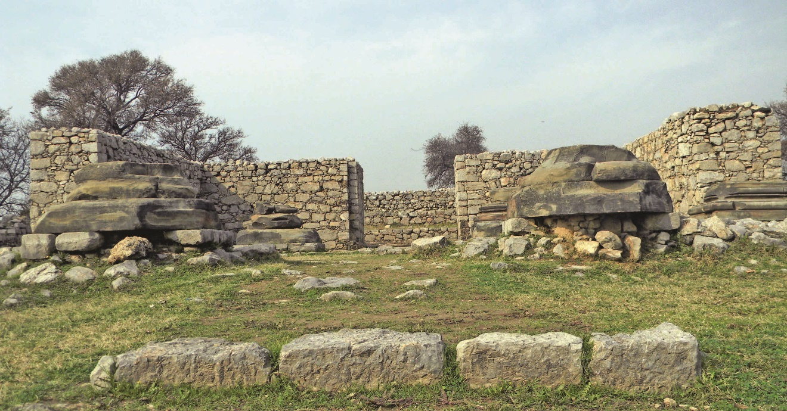

The Jandial temple dates back to 1st century BC, standing on an artificial mound, north of Sirkap City.

Taxila is known as the cradle of Buddhist civilisation, with numerous Buddhist sites. But few know that in heart of the great Buddhist civilisation there stands a Zoroastrian temple known as the Jandial Temple.

The Jandial temple dates back to 1st century BC, standing on an artificial mound, north of Sirkap City.

The resemblance of this temple to classical Greek temples is striking. The structure of the temple is in limestone and kanjur with plaster on the façade, patches of which are still intact. Kanjur is a porous form of sedimentary stone, used in Gandhara. Some large columns and pillars are constructed with massive blocks of sandstone.

Built in the Scythio-Parthian period, this is believed to be the temple described by Philostratus in his Life of Apollonius of Tyana. According to A.G Lone, a former curator of Taxila Museum, Philostratus may have spoken of this temple when he says “They saw, a temple in front of the wall, about 100 feet in length and built of shell like stone. There were brazen tablets on which were portrayed the deeds of Porus and Alexander”.

Behind the main building is a set of stairs that leads to a platform where a Parthian fire Sanctuary probably existed in the 1st century BC.

Late veteran scholar and historian A.H. Dani, in his book ‘History of Civilisations of Central Asia’ notes that “the remains of a Zoroastrian fire temple were shown from Jandial, said to have been built by the Indo-Parthians”.

Mahmoodul Hasan Shah, assistant director in the federal directorate-general of archaeology and museums, quoting Dr A.H. Dani, said: “The Jandial temple was found at the same place where Alexander the Great erected his tent.”

He said that the Greek rulers of Taxila performed religious ceremonies of their own faith at this temple.

**Bhir Mound:**

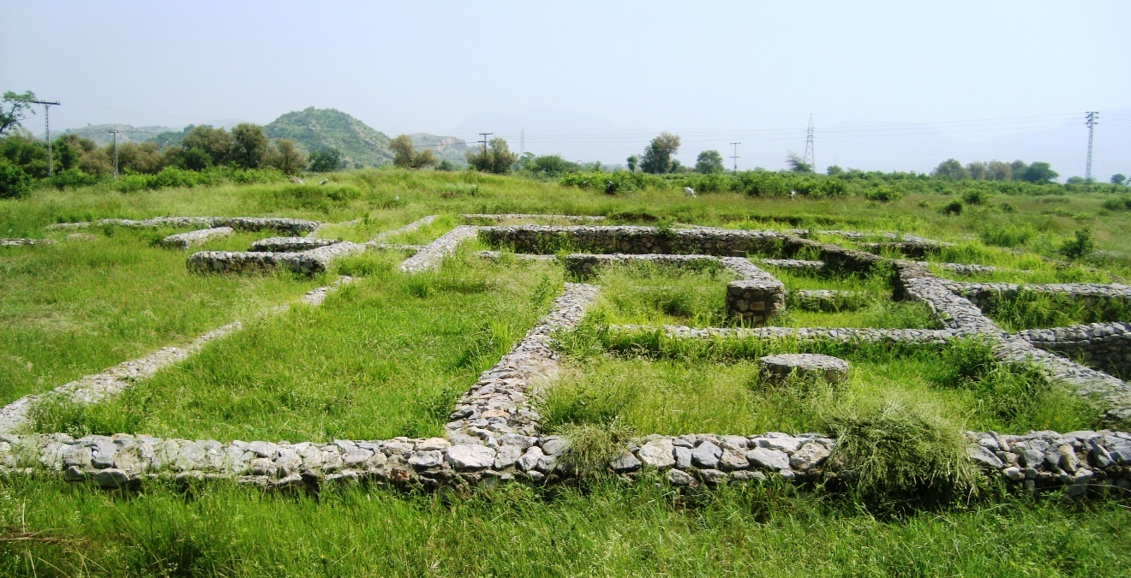

The oldest part of [Taxila](https://www.livius.org/place/taxila/) is Bhir, which consists of several building phases:

1. the oldest stratum, usually dated to the sixth and fifth centuries BCE, although literary sources suggest that the city is a bit older;
2. the fourth century, in which raja Ambhi entertained [Alexander the Great](https://www.livius.org/articles/person/alexander-the-great/) in 326;
3. the stratum of the [Mauryan](https://www.livius.org/articles/dynasty/maurya/) empire, third century;
4. and the uppermost stratum, which is everything after the Mauryan period.

The division between the first and second strata is a bit artificial. Even worse, the common identification of the oldest part of the city with the presence of the [Achaemenid](https://www.livius.org/articles/dynasty/achaemenids/) king [Darius the Great](https://www.livius.org/articles/person/darius-the-great/) in India in ca. 518 BCE is not based on archaeological finds. In his own texts, Darius claims to have conquered the Indus country, but until now, there is no archaeological confirmation. It would help if we found a Persian cuneiform tablet. So far, only one Persian coin has been reported.

There is some continuity from the oldest to the youngest levels. The main street has been found on the same place in every stratum. The rest of the town changed considerably in the course of the centuries. It consisted of irregular, zigzag, small streets and housing blocks made of mud bricks, stones and timber. There was a building that is usually interpreted as a temple ("the pillared hall") and it is said that in the palace, the Mahabharata was recited for the very first time. note

In 316, the Mauryan king Chandragupta of Magadha (321-297), the founder of the Mauryan dynasty, conquered the Punjab, which had become destabilized after the [Macedonian](https://www.livius.org/articles/place/macedonia/) invasion. Taxila lost its independence and became a mere provincial capital. Still, the city remained extremely important as center of administration, education and trade.

During the reign of Chandragupta's grandson Ashoka, Buddhism became important and the first monks settled in Taxila. They built the stupa called Dharmarajika, "the tomb of the real law lord", i.e., the Buddha, because Ashoka had sent relics to several places in his empire. At the same time, Taxila was rebuilt.

In c.184, the Greeks, who had maintained a kingdom in [Bactria](https://www.livius.org/articles/place/bactria/), invaded Gandara and the Punjab again. From now on, there was a Greek king living in Taxila, Demetrius. He seems to have ordered the rebuilding of the town on the plains north of Bhir mound. This second second city is called the [Sirkap](https://www.livius.org/place/taxila/taxila-photos/taxila-sirkap/).

The greatest monument of Bhir mound, however, cannot be shown: the scholars. Panini, the author of a famous book on Sanskrit grammar, lived in Taxila; Caraka, a famous master of medicine had a house on Bhir mound too; and Kautilya, the Brahman adviser of Chandragupta Maurya and author of a guide to statecraft, the Arthasastra, was a resident of Taxila as well.

**Jaulian University:**

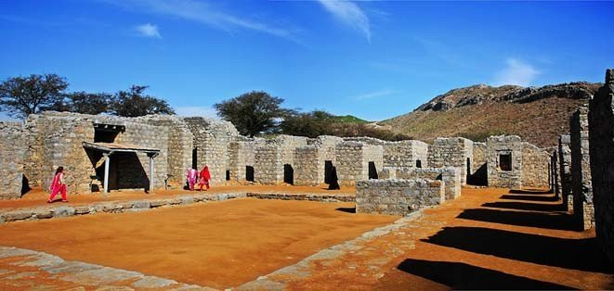

Jaulian was once a thriving ancient city and centre of learning, especially regarding the Buddhist art and architecture of Gandhara.

According to Abdul Nasir Khan, the curator of Taxila Museum, in the Buddhist texts, which is known as Jatakas, it is specified that Taxila was the city where Aruni and his son Setaketu received their education.

Mr Khan said Jaulian was constructed between the 2nd and 4th centuries in the early days of Buddhist expansion out of the Indian subcontinent in the ancient state of Gandhara. It played a key role in the spread of Buddhism along the Silk Road.

In 2 BC Buddhism was adopted as the state religion which flourished and prevailed for more than 1,000 years, mainly from this area.

According to A.G. Lone, a senior archaeologist from the Department of Archaeology and Museums, Jaulian consists of the main stupa and 27 subsidiary stupas located around it, and two adjacent courts. An additional 59 chapels are located around the courts and feature scenes from Buddha’s life.

“Today, remains of this ancient university comprise mainly structures related to monastic life, including monk cells, an assembly hall and kitchen and store rooms.”

According to Mr Lone, 27 votive stupas (small practicing stupas) surround the main stupa and feature square bases topped by circular drums and domes.

He said that despite the passage of centuries, inscriptions in the Kharosthi script are still intact at the bottom of some of the stupas which feature the names and titles of their donors.

Former director of the Taxila Institute of Asian Civilisations, Dr Ashraf Khan said Julian was the significant seat of learning during the ancient Kingdom of Gandhara. History shows that this place attracted scholars from India, Afghanistan, China, Persia and Greece. He said excavations made by Sir Johan Marshal showed the place as a masterpiece of architecture.

According to Gandhara Art and Culture Association General Secretary Dr Park Kyo Soon, hundreds of coins recovered from this site displayed an amalgamation of imagery featuring Kushan royalty, Greek lettering and Buddhist imagery.

She said cultural fluidity was also visible in the blend of architectural features on the various stupas preserved at Jaulian, which proves Greek, Persian and Roman characteristics within the Buddhist complex.

Massiullah Bacha, a former site attendant, said its significance and importance for practicing Buddhists could be judged from the fact that many important dignitaries had visited the site, including in October 2014 when Buddhist monks from South Korea came to offer special prayers for world peace.

**Dharmarajika Stupa:**

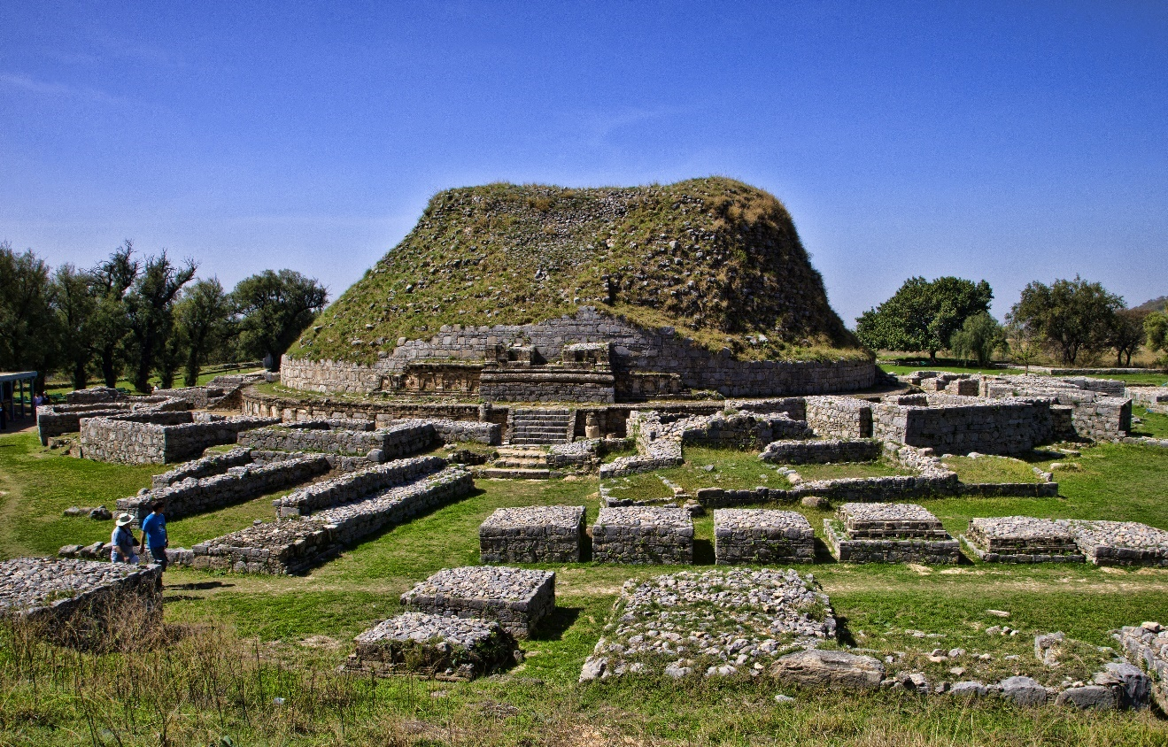

The historic Dharmarajika Stupa is located just 3km from Taxila Museum. It is not merely a stupa but a complex, having a central stupa, with several small stupas, temples and other ancient remains. Dharmarajika, commonly known as ‘Chir Tope’, is considered one of the eight largest Buddhist stupas in South Asia built around the holy relics of the Buddha by Maurya Emperor Ashoka in 3rd century BC. It is located on the bank of Dharma rivulet.

According to historic details, the name Dharmarajika is derived from ‘Dharmaraja’, a title given to Maurya Emperor Ashoka due to his services to Buddhism. According to British archaeologist John Marshall, it was actually the title of the Buddha, who was the true Dharma Raja or Lord of Law. The first excavation at the site was carried out from 1912-16 under the supervision of John Marshall.

Later in 1934-36, another excavation was conducted. Dharmarajika Complex is spread over a wide area with the main stupa about 15 metres high and 50 metres in diameter. Several round-shaped stupas were constructed around the circular structure. Another square shape medium size stupa is also located at a side of the complex, which bears the engraved small structures of Buddha on its outer walls.

There are several Buddhist temples located in the complex. It is assumed that different structures were constructed around the stupa during different periods. The stupa was badly damaged during the earthquake in 40 AD, however it was rebuilt twice by the Khushana rulers.

**KARACHI**

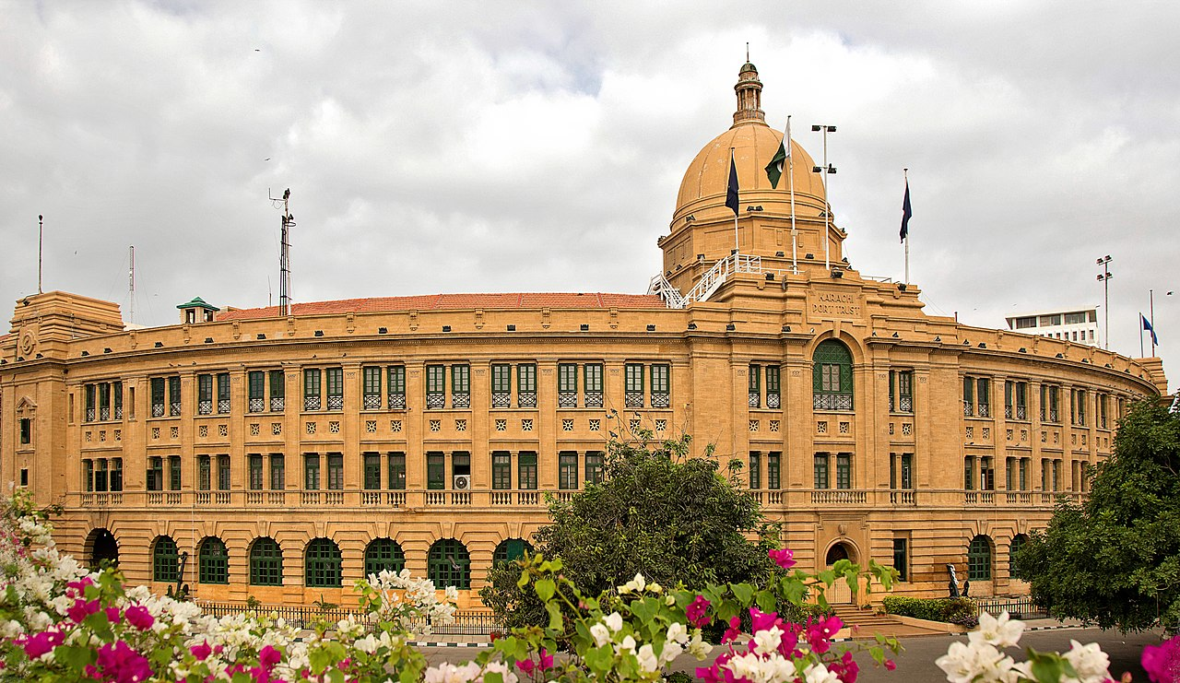

Karachi known as the city of lights is the [largest city in Pakistan](https://en.wikipedia.org/wiki/List_of_most_populous_cities_in_Pakistan) and the [twelfth largest city](https://en.wikipedia.org/wiki/List_of_largest_cities) in the world. It is the capital of the Pakistani province of [Sindh](https://en.wikipedia.org/wiki/Sindh). Ranked as a [beta-global city](https://en.wikipedia.org/wiki/Global_city), the city is Pakistan's premier industrial and financial center. Karachi is Pakistan's most cosmopolitan city, linguistically, ethnically, and religiously diverse, as well as one of Pakistan's most secular and socially liberal cities. With its location on the [Arabian Sea](https://en.wikipedia.org/wiki/Arabian_Sea), Karachi serves as a transport hub, and is home to Pakistan's two largest seaports, the [Port of Karachi](https://en.wikipedia.org/wiki/Port_of_Karachi) and [Port Bin Qasim](https://en.wikipedia.org/wiki/Port_Qasim), as well as Pakistan's busiest airport, [Jinnah International Airport](https://en.wikipedia.org/wiki/Jinnah_International_Airport).

Though the Karachi region has been inhabited for millennia, the city was founded as the fortified village of Kolachi in 1729. The settlement drastically increased in importance with the arrival of [British East India Company](https://en.wikipedia.org/wiki/British_East_India_Company) in the mid 19th century. The British embarked on major works to transform the city into a major seaport, and connected it with their extensive railway network. By the time of the [Partition of British India](https://en.wikipedia.org/wiki/Partition_of_British_India), the city was the largest in Sindh with an estimated population of 400,000. Following the [independence of Pakistan](https://en.wikipedia.org/wiki/Independence_Day_(Pakistan)), the city's population increased dramatically with the arrival of hundreds of thousands of Muslim refugees from India. The city experienced rapid economic growth following independence, attracting migrants from throughout Pakistan and South Asia. According to the [2017 census](https://en.wikipedia.org/wiki/2017_Census_of_Pakistan), Karachi's total population was 16,051,521 and its urban population was 14.9 million. Karachi is one of the world's fastest growing cities, and has communities representing almost every ethnic group in Pakistan. Karachi is home to more than two million [Bangladeshi immigrants](https://en.wikipedia.org/wiki/Bengalis_in_Pakistan), a million [Afghan refugees](https://en.wikipedia.org/wiki/Afghans_in_Pakistan), and up to 400,000 [Rohingyas](https://en.wikipedia.org/wiki/Rohingya_people_in_Pakistan) from [Myanmar](https://en.wikipedia.org/wiki/Myanmar).

**Mizar-e-Quaid:**

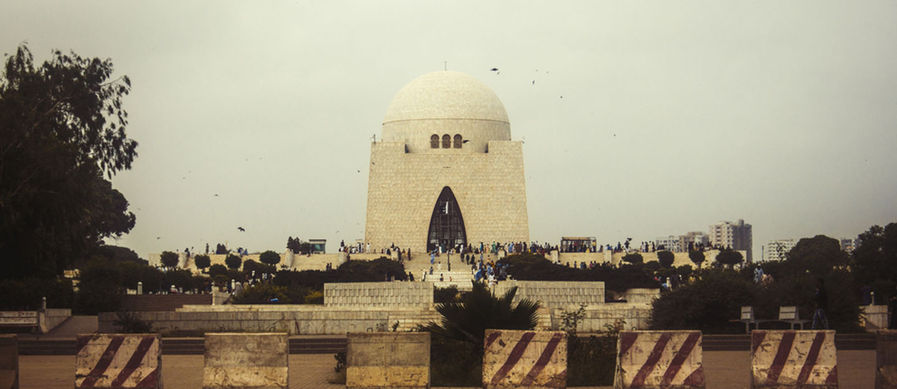

Mazar-e-Quaid is, hands down, one of the most important historical landmarks in the City of Lights. Surrounded by lush green lawns and well-carpeted tracks, the tomb is, in fact, one of the most iconic places in the country.

Mazar-e-Quaid, is the final resting place of Muhammad Ali Jinnah. After the death of the founder of Pakistan, the government decided to build his mausoleum at the highest point in Karachi.

In 1957, the government decided to conduct a worldwide competition for the designs of the tomb. Although a few submissions were shortlisted, Fatima Ali Jinnah, the sister of Quaid-e-Azam, decided to contact an Indian architect Yahya Merchant. The mausoleum was officially inaugurated in 1971.

Jinnah Mausoleum is covered in white marble and is considered among the most famous landmarks of Pakistan. Photos of this place are often used to represent Karachi in the press and mass media. In a way, Mazar-e-Quaid is to Karachi what Minar-e-Pakistan is to Lahore – arguably the most widely-recognized symbol of the city.

It is covered in white marble, which covers both the interior and exterior of the structure. The mausoleum comprises a dome made from stucco and copper latticework can be seen at the four-pointed arch entrances.

The National Mausoleum is surrounded by a large garden and beautiful walking tracks that were recently renovated. The roads surrounding the park and mausoleum have also been repaired to facilitate tourists visiting the area. In 2016, a non-governmental organization, Shehri – Citizens for a Better Environment, planted 100 sapling at Mazar-e-Quaid as part of its “Million Trees Campaign.”

The National Mausoleum is located on M.A. Jinnah and in close proximity to The Dawood Foundation (TDF) Ghar and [Cosmopolitan Society](https://www.zameen.com/area-guides/cosmopolitan-society-karachi/). It falls under the jurisdiction of [Jamshed Town](https://www.zameen.com/area-guides/jamshed-town-karachi/) which is among the top neighborhoods of the metropolitan city. Some nearby localities are [Britto Road](https://www.zameen.com/area-guides/britto-road-karachi/), [Tipu Sultan Road](https://www.zameen.com/area-guides/tipu-sultan-road-karachi/" \t "_blank), [Saddar Town](https://www.zameen.com/area-guides/saddar-town-karachi/), and [Shaheed-e-Millat Road](https://www.zameen.com/area-guides/shaheed-e-millat-road-karachi/), and Soldier Bazaar.

**Mohatta Palace Museum:**

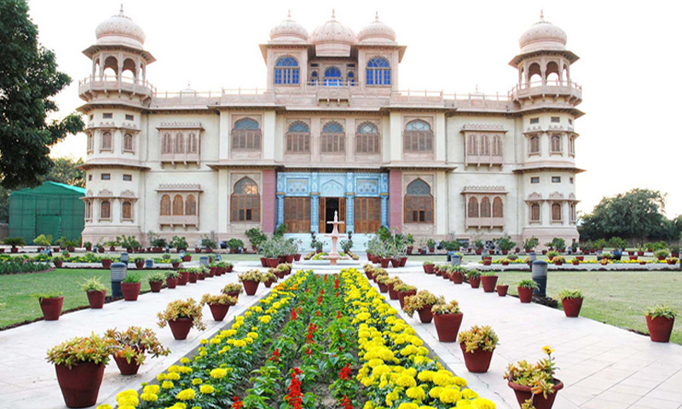

There is particularly a certain building in Clifton which looks like a palace and is a very popular attraction for anyone who comes here — the Mohatta Palace.

Currently a centre for cultural activities, the Mohatta Palace was constructed by a wealthy businessman of Karachi, Shivratan Chandraratan Mohatta.

The double-storeyed structure covers an area of 18,000 square feet. There hasn't existed a single structure that could match the area that Mohatta Palace covers, neither before nor after Partition.

Upon entering the palace, you first notice the beautifully coloured windows on the exterior, a wall of stone, an arch and minarets; a stunning view of architectural splendour.

The rooms on the first floor are luxurious and royal in their setting, an absolute delight to be in. The second floor is no less beautiful. It's hard to look at a room and imagine it being used by a singular person.

Even today, if you go all the way up to the rooftop of the building, it might be possible to catch a view of the sea, though dull residential high-rises have surrounded the Mohatta Palace so completely that even the winds from the sea cannot reach their once favourite destination. Back when it was constructed, the occupants of the Mohatta Palace could enjoy not only the sea breeze, but a view of the then clean and unpaved seashore, too.

On the rooftop is a magnificent structure with a central dome surrounded by smaller ones. This was meant to protect inhabitants from the severe heat of direct sunlight. In addition to the central structure, the building has four other minaret-domes on its corners.

The official name of the palace is *Qasr-e-Fatima (As Fatima Jinnah, sister of Quaid-e-Azam Muhammad Ali Jinnah also stayed there after partition)* . However, as with many such places in the country and the region, no one knows it by that name. Mr Mohatta must be content with a kernel of revenge, knowing that after all the palace has been through, it is still known to the world as the Mohatta Palace.

**Frere Hall:**

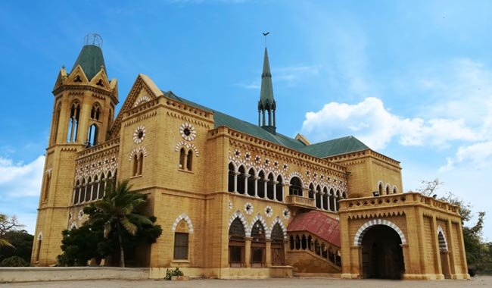

While talking about the best things in Karachi and leaving “Frere Hall” behind is not so fair. It is one of the best and most visited tourist's spots with unique attractions. Let’s find out those in today’s post.

Frere Hall is a significant architecture of the British era. It was built for honoring Sir Henrey Frere. Sir Henry contributed a lot for the economic growth and also strived hard to make Sindhi as the official language of Sindh.

Frere Hall remained the largest library of Sindh for so many years which was then closed due to some issues. The hall was reopened in 2011 for the public.

Frere Hall is masterly located between Abdullah Road and Fatima Jinnah Road. The Hall lies on Civil Lines next to Marriott Hotel.

Frere hall was initiated in the British era as a Town Hall in 1865. The Hall served as a house for King Edward Vll and Seth Dinshaw.

In 1877, British rulers accumulated in the Hall to establish rules for the game of badminton.

The Architecture of Frere hall is not so ordinary. In fact, this is the most fascinating thing about the hall. 12 architects proposed the architecture and design of Hall while only one ( Lt. Col Clair Wilson) was selected. The hall took 180,000 for its construction. The funds were raised by the municipality.

The style of Frere Hall is very Gothic and Venetian. It is built by using yellowish limestones and red/grey sandstones. The architecture has a touch of British and local components.

Isn’t it so dramatic to even read about? Just imagine the scenes when you actually pay a visit.

The pillars and walls have unique and intricate mosaic carvings. The yellowish stones are imported from Rajasthan and Thar to give it a more beautiful finishing.

Liaquat library named after Prime Minister of Pakistan Liaquat Ali Khan is present in the ground floor of Hall. It is the largest library with more than 70,000 books. You can get all the books, guides, dictionaries, and manuscripts which are difficult to find anywhere else.

Now, this is what we call amazing!

Are you a fan of 1800s Architecture? Do you find architecture fascinating? If yes, then Frere Hall is nothing less than a paradise to you. It is the greatest hub of Pakistani and British history.

Besides books and manuscripts, Frere Hall has so much to offer to nature lovers. The hall is surrounded by lush and meticulous gardens. Their beauty is to die for. These luscious gardens together with gothic architecture go really well.

The construction of gardens was done in 1888. Before independence, the lawns were known as “king’s Lawn” and Queen’s Lawn” due to their beauty. The garden was renamed to Jinnah Garden after Pakistan got independence.

Frere Hall is a hub of festivals as many festivals take place inside this hall. It simply means the hall has so much to offer along with history. How cool is that!

Food festivals, art festival, culture festivals, and spring festivals are remarkable amongst all. It is also a great place for exhibiting your paintings.

If you really want to make your visit to Karachi worth the effort than prioritize your visit to Frere Hall. It is a great informative place in the day time and also a magnificent view provider at night.

**Clifton Beach:**

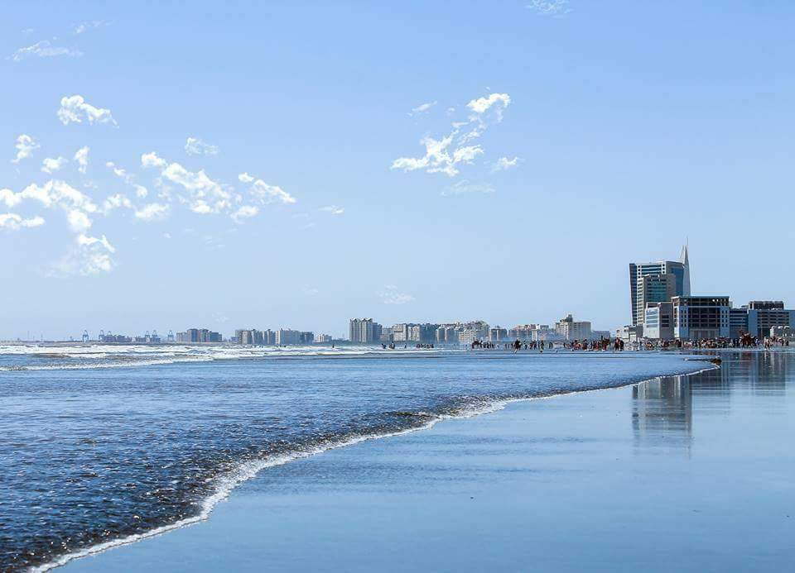

Clifton Beach, also known as Sea View, in [Karachi](https://en.wikipedia.org/wiki/Karachi), [Sindh](https://en.wikipedia.org/wiki/Sindh), [Pakistan](https://en.wikipedia.org/wiki/Pakistan) is located on the [Arabian Sea](https://en.wikipedia.org/wiki/Arabian_Sea). It stretches from Karachi to [Ormara](https://en.wikipedia.org/wiki/Ormara" \o "Ormara) ([Balochistan](https://en.wikipedia.org/wiki/Balochistan" \o "Balochistan)). The beach is very popular in Pakistan. It is open 24/7 for the general public.

Karachi is the most prominent coastal city of Pakistan and beach lovers here have many opportunities to visit different beaches bordering the Arabian Sea. Clifton Beach is purported to give the best value in leisure and recreational opportunities for fun seekers and beach lovers.

In recent times, the area surrounding the beach has seen massive commercial activity as it is located in one of the most sought after localities in Karachi.

The beach is now home to multiple local leisure activities including camel rides, buggy rides, horse rides, plastic plane flying among others. The Seaview Apartments across from the beach is a gated residential area which is rated among the top properties in the city. Other apartments and villas which can be seen along the Clifton beach coasts are becoming popular as well.

Camel and horse rides on the sands are popular, while stands sell cold drinks, chai (tea) and grilled corn. A park and promenade was on the verge of completion when we visited, where you can stroll for a small entry fee. The main roundabout near the beach has plenty of buses, autorickshaws and taxis, many heading for Saddar (a taxi will set you back Rs100.

**Tooba Mosque:**

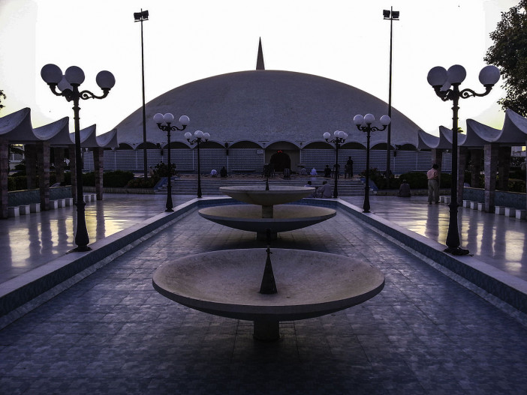

Tooba Mosque regionally known as the “Gol Masijd” is a distinctively and beautifully architectural design mosque situated in Phase 02 of DHA (Defense Housing Authority), Karachi. This picturesque mosque was established in 1969 in DHA, Karachi. It is merely off main Korangi road.

This mosque is entirely developed with white marble. The diameter of dome is almost 65m and its level on low encircling wall with no middle pillars. The Tooba Mosque is composed of only one minaret standing 37m in altitude. The Masjid-e-Tooba primary prayer hall having a potential of covering 5000 people.

It was established keeping audibility in mind. An individual talking inside one side of the dome can be listened at the other side. The mosques was architected and designed by Dr. Babar Hamid Chauhan (Pakistani Architect).

The outstanding beauty of the mosque is really elegant as it does not comprise of fancy artistry. All the work of mirror they had in the interior of mosque is very classy and simple. There is a lush green lawn outside to make some space so that the visitors can walk around and praise its beauty be saying Subhan’Allah frequent times. It is an embellished impressive masjid and significant symbol of Islamic Culture.

**Pakistan Maritime Museum:**

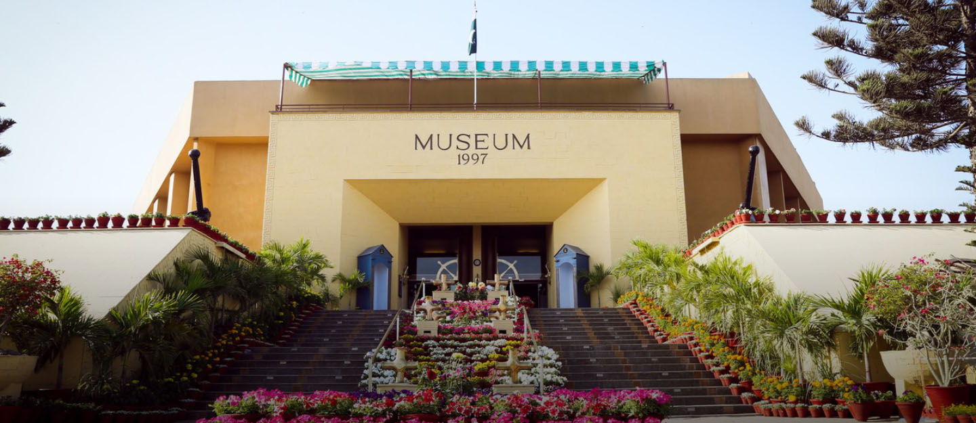

Karachi is home to a number of museums, but none are as splendidly maintained as the Pakistan Maritime Museum and the Pakistan Air Force Museum. Thus, if you’re exploring the best that Karachi has to offer, don’t forget a trip to Pakistan Maritime Museum, which is home to a collection of objects and artefacts relating not just to the Pakistan Navy, but also to Pakistan’s history.

As the name rightfully implies, the Maritime Museum is managed and operated by Pakistan Navy. The museum is spread across 18 acres of land, taking into account the beautiful park accompanying the museum. Being situated near PNS Karsaz and the National Stadium on Karsaz Road makes it easier for anyone living in any part of Karachi to visit the museum and take pride in the many achievements of their navy. The main building of the museum covers a mammoth 50,000 square footage with three floors comprising six different galleries. There’s also an auditorium with a capacity for 60 people, a library, as well as a historical archive.

The idea of a naval museum was first considered in 1978, but the construction actually began in 1993. It took 4 years to complete, and the Pakistan Maritime Museum opened its doors to the public in 1997. The purpose behind its establishment was to promote awareness among the general populace about naval history, artefacts, and equipment, most of which are strongly linked to our country’s heritage. The exhibits on display include vintage naval equipment, paintings, murals, as well as interactive booths where you can get more information about the relics on display.

Among other things, the Pakistan Maritime Museum comprises the following galleries, every one of which is a must-visit:

* Maritime History Gallery
* Pakistan Navy Gallery
* Former Chiefs of Pakistan Navy Gallery
* Karachi Harbour Gallery
* Aquarium Gallery
* Science Gallery

Besides the galleries mentioned above that are located indoors, the grounds of the museum are an open-air museum, with a large lake that is home to a number of anchored exhibits. The first of these is the Ex-PNS Mujahid minesweeper ship, followed by the Ex-PNS Hangor historic submarine, and the Ex-PNS barge. Other exhibits set up on the well-manicured lawns include a replica of the Manora lighthouse, an Atlantic aircraft, vintage guns, and torpedoes, as well as the saluting gun and coffin carriers of Quaid-e-Azam Muhammad Ali Jinnah and Liaquat Ali Khan.

Out of the above, you can tour the submarine, the ship, and the aircraft from the inside at an additional fee. You can also climb up to the top of the lighthouse for a fabulous view of the whole park.

**HYDERABAD**

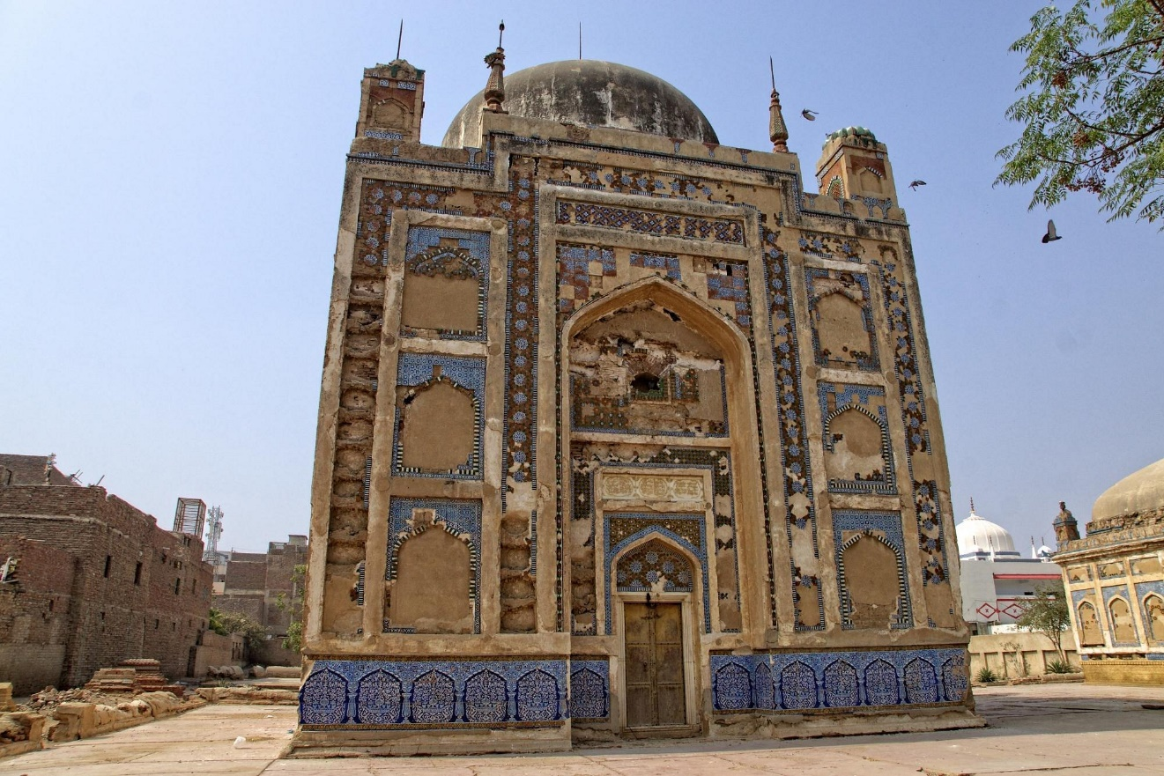

Hyderabad, also spelled Haydarabad, city, south-central [Sind](https://www.britannica.com/place/Sindh-province-Pakistan) province, southeastern [Pakistan](https://www.britannica.com/place/Pakistan). It lies on the most northerly hill of the Ganjo Takkar ridge, just east of the [Indus River](https://www.britannica.com/place/Indus-River). One of the largest cities in Pakistan, it is a communications centre, connected by rail with [Peshawar](https://www.britannica.com/place/Peshawar) and [Karachi](https://www.britannica.com/place/Karachi) and with Indian railways via the border towns of Khokhropar and Munabao.

Founded in 1768 on the site of the ancient town of Nirun-Kot by Ghulam Shah Kalhora, the saintly ruler of Sind, it was named for the Prophet Muhammad’s son-in-law, ʿAli, also known as Ḥaydar. It remained the capital of Sind under the [Talpur](https://www.britannica.com/topic/Talpur) rulers, who succeeded the Kalhoras, until 1843 when, after the nearby battles of Miani and Dabo, it surrendered to the British and the capital was transferred to Karachi.

Incorporated as a municipality in 1853, it is an important commercial and industrial centre. Economic activities include textile, sugar, cement, and hosiery mills, and the manufacture of glass, soap, ice, paper, and plastics. There are hide tanneries and sawmills. Ornamented silks, silverwork and goldwork, and lacquerware are also produced. Noteworthy antiquities include the tombs of the Kalhora and Talpur rulers, palaces of the former *amir*s of Sind, and a fort (built 1782). Newly developed settlements and industrial estates surround the congested old city area. Characteristic of the city are *badgir*s (“wind-catchers”) fixed to housetops to catch sea breezes during the hot season. A hospital, municipal gardens, zoo, sports stadium, and several literary societies are in the city. The Ghulam Muhammad ([Kotri](https://www.britannica.com/place/Kotri-Barrage)) [Barrage](https://www.merriam-webster.com/dictionary/Barrage), including a lock to [facilitate](https://www.merriam-webster.com/dictionary/facilitate) river traffic, provides flood control. The University of Sind with numerous [affiliated](https://www.merriam-webster.com/dictionary/affiliated) colleges, founded in 1947 in Karachi and moved to Hyderabad in 1951, lies across the Indus. Other education needs are served by numerous government colleges, the Liaqat Medical College, and specialized vocational institutions.

**Sindh Museum:**

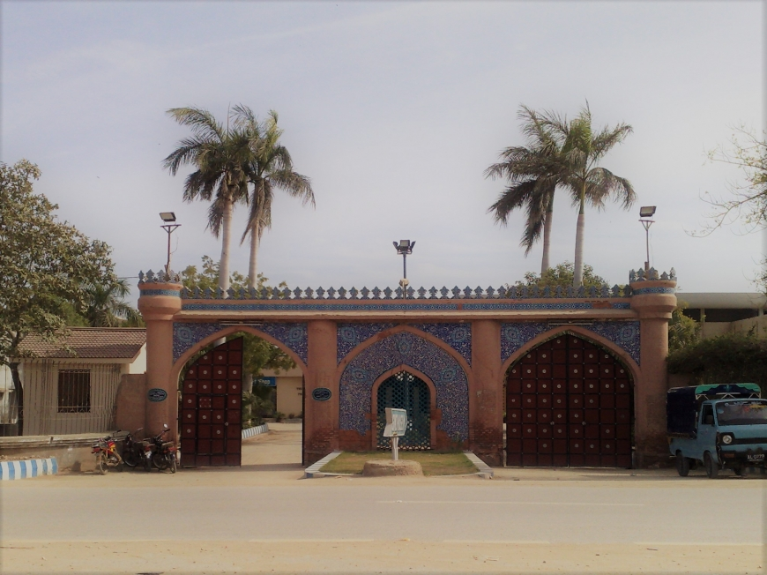

The Sindh Museum is located in Hyderabad that is the second largest city of Sindh. The objective behind the establishment of museum was collection and preservation of Sindhi culture and traditions. The main focus of the museum is on history and heritage of Indus valley civilization. The museum actually depicts the life style of people who lives in Sindh especially in rural areas.  
  
Sindh museum promotes Sindhi culture and give awareness to tourists about old civilization and cultures prevailing in Sindh.  This museum displays the great art of Sindh’s civilizations Aryans and Indus civilization. This museum helped various scholars to know about history of Sindh and the life style of people living in Sindh  
  
Sindh museum covers all aspects of life of Sindhi people their living style, their working style and their traditions. Different materials of Soomra, Talpur and Kalhora rulers are present in the museum. One can find swords that are used by rulers in different wars. Other defense material is also present which was used by rulers to defend their territories. Apart from that one can see different machines used during cultivation of crops. Sindh Museum has models of people who are working on different jobs such as working for manufacturing of handicrafts, working on conversion of cotton into cloths or working of women in the home. Models of ancient civilizations are also placed in to show visitors that how the people of these civilizations were living and working.  In early times people of Sindh were mainly dependent on their animals for purpose of survival. They get milk from them and use it as a food. So animal models were also present  
  
Museum is full of handicrafts. The artwork is impressive. Combination of different colors has made every handicraft a different one. Simple pots and water storage pots are the remaining of early civilization. One can find a complete environment of Sindhi rural culture in the museum. How women’s live and do work in their homes is also prominent factor. Even environment of a kitchen is also present in the museum. Different wearing of women including different dresses, footwears and bangles are also part of museum. In rural areas people live in joint families so joint family system model is also present in Sindh Museum.  
  
Different music instruments are also part of museum. Every instrument has its own specialty in terms of sound. Reflection of Sindhi culture is also present in the museum. The marriage ceremony and other events are show in their true pictures. This shows the richness and originality of culture.  
  
Other than that different monumental in different languages are also present there. The museum reflects some very good days of Sindhi culture when people live together and shares problems with each other. Museum also reflects unity of the Sindhi people which they lack today. As they were living in joint family system they address problems of each other and live with peace and calm. As at early times there was no technology, so people work manually.  
  
Similarly like other places it is a tourist spot. People from different places come here and learn a lot about Sindhi culture and traditions.

**GWADAR**

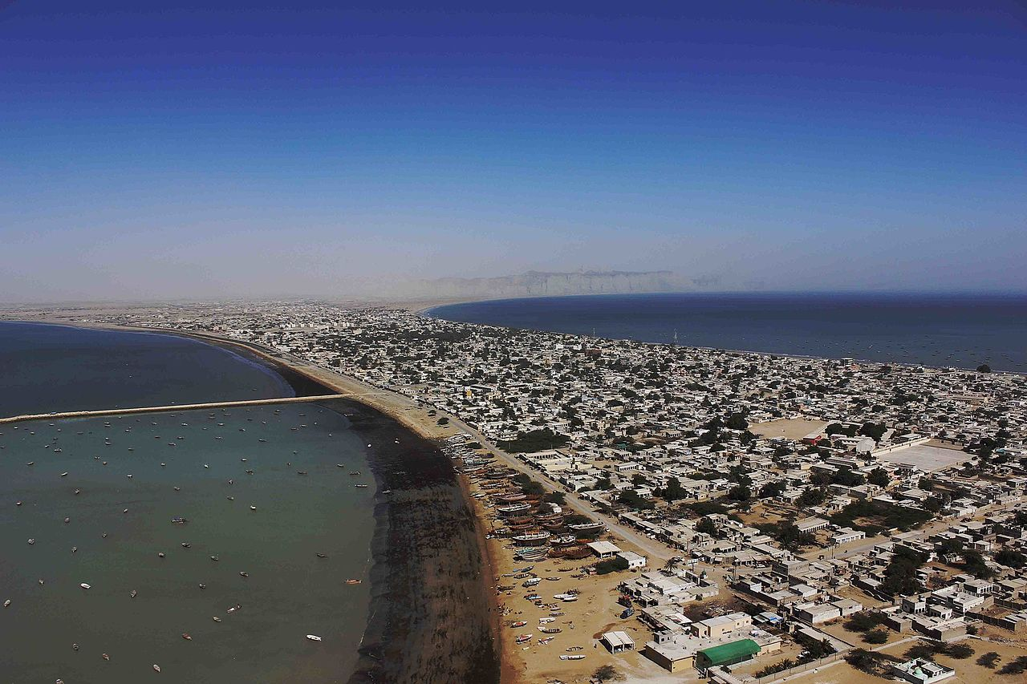

Gwadar, a port city of Pakistan located on the southwestern coast of Baluchistan province. This city is present on the shores of the Arabian sea opposite to Oman.

Talking about its history, Gwadar was a medium sized settlement with an economy that was largely supported artisanal fishing. The strategic importance of its location was first recognized in 1954 when it was spotted as a suitable site for a deep-water port by the United States Geological Survey at the request of Pakistan. The area's potential to be a serious deep-water port remained untapped under successive Pakistani governments until 2001, when construction on the primary phase of Gwadar Port was initiated. The first phase was inaugurated in 2007 at a complete cost of $248 million. The port initially remained underutilized after construction for a variety of reasons, including lack of investment, security concerns, and the Government of Pakistan's failure to transfer land as promised to the port operator, Port of Singapore Authority.

Pakistan and [China](https://en.wikipedia.org/wiki/China) have announced their intention to develop the [China–Pakistan Economic Corridor](https://en.wikipedia.org/wiki/China%E2%80%93Pakistan_Economic_Corridor) (CPEC), which in turn forms part of China's ambitious [One Belt, One Road](https://en.wikipedia.org/wiki/One_Belt,_One_Road). Gwadar features heavily in CPEC, and is also envisaged to be the link between the [One Belt, One Road](https://en.wikipedia.org/wiki/One_Belt,_One_Road) and [Maritime Silk Road](https://en.wikipedia.org/wiki/Maritime_Silk_Road) project. The city will also be the site of a [floating liquefied natural gas](https://en.wikipedia.org/wiki/Floating_liquefied_natural_gas) facility that will be built as part of the larger Gwadar-Nawab shah segment of the [Iran–Pakistan gas pipeline](https://en.wikipedia.org/wiki/Iran%E2%80%93Pakistan_gas_pipeline) project. In September 2016, the Gwadar Development Authority published a [request for tenders](https://en.wikipedia.org/wiki/Request_for_tender) for the preparation of expropriation and resettlement of Old Town Gwadar.

**Gwadar Bay:**

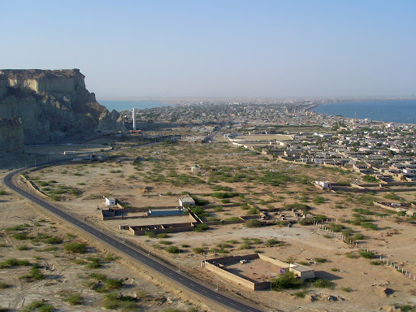

Gwadar Bay, Persian Khalij-e Gavater, inlet of the Arabian Sea indenting the sandy Makran coast at the Iran–Pakistan border. It is about 20 miles (32 km) long and 10 miles (16 km) wide. Bay, concavity of a coastline or reentrant of the sea, formed by the movements of either the sea or a lake.

Gwadar Bay is located in the Gulf of Oman on the maritime border of Pakistan and Iran on the shores of the Arabian Sea in the western province of Balochistan, Chabahar. The name is from Persian, Khalij-e Gavader or “Gulf of Gwadar” on the Arabian Sea. The Dashtiari River flows into it from the northwest, and the Dasht from the northeast. The town of Gwadar, Pak., lies on the Arabian Sea coast about 30 miles (48 km) to the east of Gwadar Bay.

Gwadar Bay flows into Nahr River in Pakistan and in Bahoocalat River in Iran. Doing business in Gwadar bay has a long history. The traders passed from India to Africa through this bay’s waters. The closest place from Iran to Oman is a small village called Gwadar that has 160.000 populations. Most people in this area do fishing and Mat weaving.

This bay was the center of exporting shrimp which you can still see this business in this area. If you want to visit Chabahar, don’t miss visiting Gwadar bay and a castle near it because you can take a walk on the beach and enjoy sunset. You can also watch crabs marching on the beach. It’s interesting to know that many birds immigrate to this bay in the first of autumn. Visitors of chabahar tour can see other chabahar tourist attractions such as Lipar wetland and Gandou that is a protected area.

**Gwadar Sea Port:**

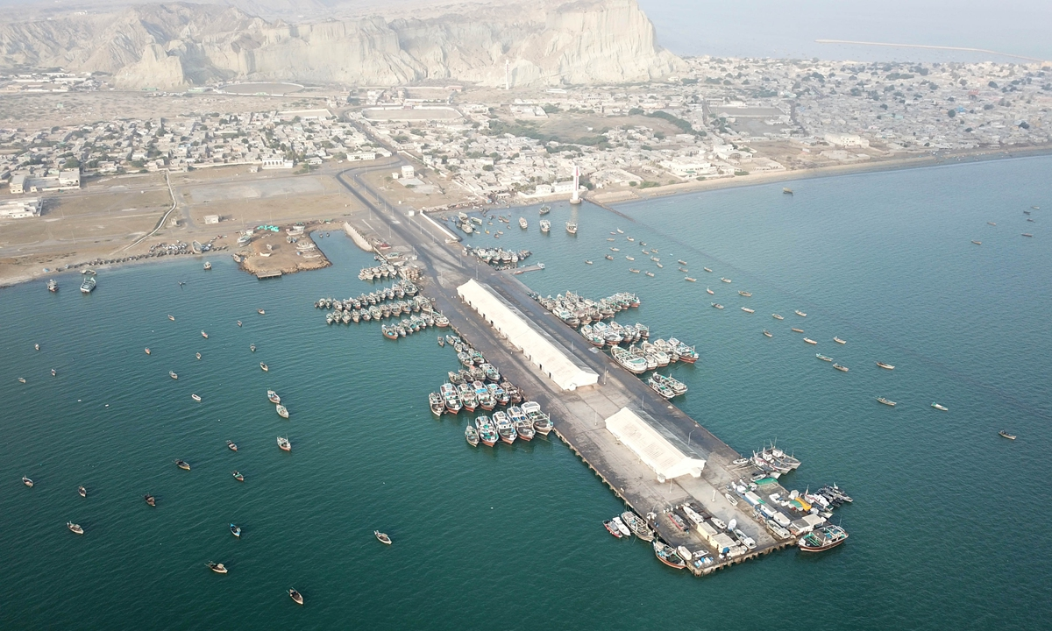

The Gwadar Port is the [deepest sea port](https://en.wikipedia.org/wiki/Deep_water_port) in the world situated on the [Arabian Sea](https://en.wikipedia.org/wiki/Arabian_Sea) at [Gwadar](https://en.wikipedia.org/wiki/Gwadar) in [Balochistan](https://en.wikipedia.org/wiki/Balochistan,_Pakistan" \o "Balochistan, Pakistan) province of [Pakistan](https://en.wikipedia.org/wiki/Pakistan) and is under the administrative control of the [Maritime Secretary of Pakistan](https://en.wikipedia.org/wiki/Maritime_Secretary_of_Pakistan) and operational control of the China Overseas Port Holding Company. The port features prominently in the [China–Pakistan Economic Corridor](https://en.wikipedia.org/wiki/China%E2%80%93Pakistan_Economic_Corridor) (CPEC) plan, and is considered to be a link between the [Belt and Road Initiative](https://en.wikipedia.org/wiki/Belt_and_Road_Initiative) and the [Maritime Silk Road](https://en.wikipedia.org/wiki/Maritime_Silk_Road) projects. It is about 120 kilometres southwest of [Turbat](https://en.wikipedia.org/wiki/Turbat" \o "Turbat), and 170 kilometres to the east of [Chabahar Port](https://en.wikipedia.org/wiki/Chabahar_Port).

Gwadar's potential to be a deep water sea port was first noted in 1954, while the city was still under Omani sovereignty. Plans for construction of the port were not realised until 2007, when the port was inaugurated by [Pervez Musharraf](https://en.wikipedia.org/wiki/Pervez_Musharraf) after four years of construction, at a cost of $248 million.

In 2015, it was announced that the city and port would be further developed under CPEC at a cost of $1.62 billion, with the aim of linking northern Pakistan and western China to the deep water seaport. The port will also be the site of a [floating liquefied natural gas](https://en.wikipedia.org/wiki/Floating_liquefied_natural_gas) facility that will be built as part of the larger $2.5 billion Gwadar-Nawabshah segment of the [Iran–Pakistan gas pipeline](https://en.wikipedia.org/wiki/Iran%E2%80%93Pakistan_gas_pipeline) project. Construction began in June 2016 on the [Gwadar Special Economic Zone](https://en.wikipedia.org/wiki/Gwadar_Port#Gwadar_Special_Economic_Zone), which is being built on 2,292-acre site adjacent to Gwadar's port. In late 2015, the port was officially leased to China for 43 years, until 2059.

Gwadar Port became formally operational on 14 November 2016, when it was inaugurated by Pakistan's Prime Minister [Muhammad Nawaz Sharif](https://en.wikipedia.org/wiki/Muhammad_Nawaz_Sharif); the first convoy was seen off by the then Pakistan's [Chief of Army Staff](https://en.wikipedia.org/wiki/Chief_of_Army_Staff_(Pakistan)), General [Raheel Sharif](https://en.wikipedia.org/wiki/Raheel_Sharif). On 14 January 2020, Pakistan operationalized Gwadar Port for Afghan transit trade.

**Gwadar Beach:**

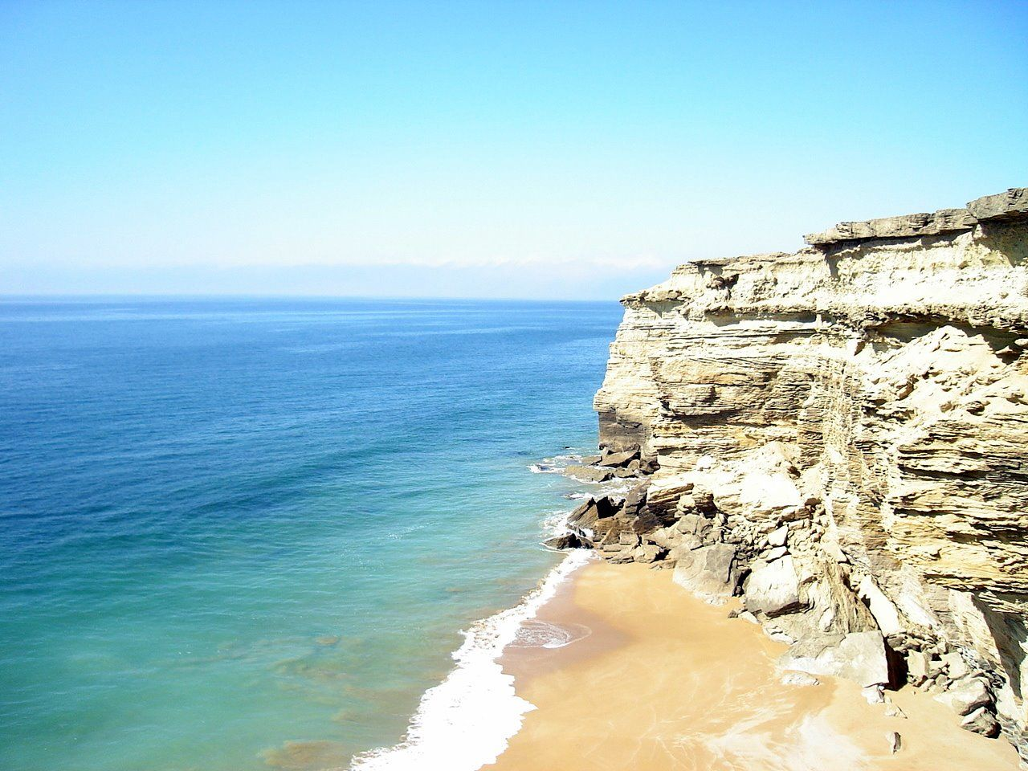

The Gwadar beach is home to astonishing wind-carved rock formations on them on one side and pristine beaches on the other side. Gwadar port beach mostly famous due to the construction of CPEC by China. It connects Pakistan to all major trading spots, providing it with major strategic importance for business as well as for tourism. It is the main place that attracts tourists and investors. Gwadar is one of the highest deep harbors in Pakistan and the world.

**Zalzala Koh (Earthquake Mounatin):**

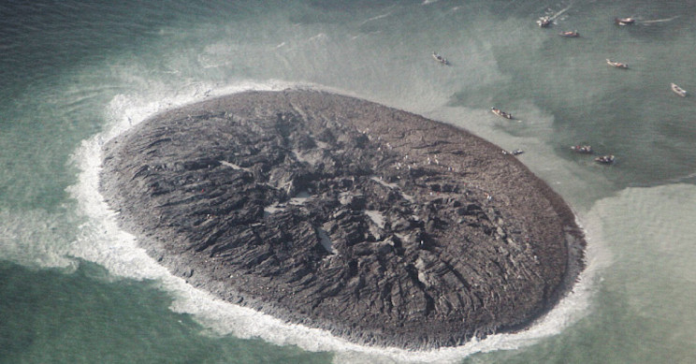

Zalzala Koh was birthed in 2013, after Pakistan's devastating earthquake that killed 800 people and destroyed 21,000 homes.

Curiously, the destructive event also led to the new island being formed by volcanic forces that were in action during the quake.

Once the earthquake subsided, Zalzala Koh was discovered off the coast of Pakistan, near the city of Gwadar. A mud volcano had pushed the soil up from the seabed.

“The island is really just a big pile of mud from the seafloor that got pushed up" Bill Barnhart, a geologist at the U.S. Geological Survey [told NASA Earth Observatory](https://earthobservatory.nasa.gov/images/82146/earthquake-births-new-island-off-pakistan) at the time.

Now, new images from NASA show that Zalzala Koh has been submerged by the sea — though it is still somewhat visible beneath the waves.

The island, which was 20 meters high, 90 meters wide, and 40 meters long when first found, was never expected to last for long; scientists immediately predicted that the tides and waves would quickly erode the muddy formation.